**Smart Manufacturing in India: Empowering MSMEs for Future Growth**

Unleashing Smart Manufacturing's Potential for MSMEs in India

**Presented by:**

**Name: Nampally Sai Kiran Varma**

**Department: Smart Manufacturing**

**Institute: PDPM IIITDMJ**

**Role: BIS Intern**

**Intern Department: (Electronics and Information Technology Department)**

**Name: Soham Wankar**

**Department: Smart Manufacturing**

**Institute: PDPM IIITDMJ**

**Role: BIS Intern**

**Intern Department: (Electronics and Information Technology Department)**

**Presented to:**

**Organization: Bureau of Indian Standards**

**Department: LITD (Electronics and Information Technology Department)**

**Acknowledgments**

Completing this report, "Empowering MSMEs: Smart Manufacturing in India," has been a journey enriched with learning and growth. We extend heartfelt gratitude to all who contributed to its success.

We appreciate the Bureau of Indian Standards (BIS) for the internship opportunity that allowed us to explore smart manufacturing and Industry 4.0.

Special thanks to Dr. Ankita Srivastava, our mentor from BIS, for her guidance and insights that shaped our research. We're thankful to IISc Bangalore and Schneider Electric for their cooperation and hospitality during our visits.

Prof. Amaresh Chakrabarti's invitation to the Industry 4.0 Research facility at IISc Bangalore added invaluable depth to our analysis.

Our gratitude to Chidanand Burji for facilitating our visit to Schneider Electric's innovative factory.

Lastly, thanks to our families, friends, and colleagues for their unwavering support.  
  
With gratitude,  
**Nampally Sai kiran Varma**  
Smart Manufacturing Engineer   
PDPM IIITDM Jabalpur  
  
**SohamWankar**  
Smart Manufacturing Engineer   
PDPM IIITDM Jabalpur

**Abstract:**

"Smart Manufacturing in India: Empowering MSMEs for Future Growth" is a comprehensive exploration of the transformative potential of smart manufacturing technologies for Micro, Small, and Medium Enterprises (MSMEs) in India. This report delves into the multifaceted landscape of smart manufacturing, its benefits, challenges, and the significant role it plays in bolstering the growth of MSMEs.

The report commences by establishing the context and significance of MSMEs in the Indian economy, followed by a clear delineation of the study's objectives. It offers an incisive overview of smart manufacturing, elucidating its profound relevance and potential for driving the growth of MSMEs in the Indian context.

Advantages and benefits of embracing smart manufacturing are expounded upon, illustrating how these technologies can catalyze operational efficiency, product quality enhancement, and market competitiveness. The complexities of technology adoption are addressed through an insightful analysis of challenges faced by MSMEs in integrating smart manufacturing practices.

The report further delves into two compelling case studies – Schneider Electric's Smart Factory and IISc Bangalore's Research Facility – showcasing real-world applications, lessons learned, and best practices in implementing smart manufacturing systems.

For MSMEs aspiring to embark on the smart manufacturing journey, the report offers a step-by-step guide encompassing essential aspects such as gradual integration strategies, technology selection, government initiatives, and the importance of upskilling the workforce.

The financial dynamics of smart manufacturing are scrutinized through a comprehensive cost analysis and the estimation of return on investment (ROI), providing pragmatic insights into the financial aspects of adopting these technologies.

Additionally, the report highlights the sustainable impact of smart manufacturing implementation by MSMEs, underscoring its potential to drive environmental sustainability and economic growth hand in hand.

In conclusion, "Smart Manufacturing in India: Empowering MSMEs for Future Growth" encapsulates a wealth of knowledge, actionable insights, and real-world examples, positioning itself as a crucial resource for MSMEs, policymakers, and stakeholders aiming to harness the power of smart manufacturing to fortify the future of Indian industry.

**CONTENTS:**

**1. Introduction 6**

1.1 Background and Significance of MSMs in india: 6

1.2 Objective of the Study 8

1.3 Overview of Smart Manufacturing and its significance for MSMEs in India. 8

**2. Advantages and benefits of adopting smart manufacturing technologies for MSMEs 10**

[2.1 Benefits and Advantages for Adopting Smart Manufacturing for MSMEs  
Table 2.1 | techonologies and their role in MSMes 10](#_heading=h.tyjcwt)

2.2 Current Challenges faced by MSMEs in adoption of Smart manufacturing technologies India 17

2.3 Importance of Collaboration Between MSMEs with Academia or Research Departments 17

**3.Case Study: 19**

3.1 Schneider ElectricSmart Factory: 19

3.1.1 Implementation of Smart Manufacturing Technologies: 20

3.1.3 Impact of Smart Manufacturing: 26

3.1.4 Lessons Learned and Best Practices: 27

3.2 IISc Bangalore Smart Factory: 27

3.2.1 Introduction to the IISc Bangalore Research Facility and its Research in Smart Manufacturing 27

3.2.2 Exploration of Cutting-edge Technologies and Innovations Used in the Smart Factory 28

3.2.3 Collaborative Initiatives of IISc Bangalore with MSMEs and Their Benefits 28

4. Step-by-step guide for MSMEs to plan and implement smart manufacturing initiatives 30

4.1 Architecture for Implementation of Smart Manufacturing: 30

4.2 Roadmap for Transitioning from Legacy Industry to Smart Industry: 31

4.2.1 Importance of gradual integration and continuous improvement: 32

4.2.2 Guidance on selecting suitable technologies and partners: 33

4.3 Government Initiatives and Support for MSMEs in Smart Manufacturing 36

4.3.1.Ministry of Micro,Small and Medium Enterprises 36

4.3.2. NASSCOM - Center of Excellence in IOT & AI - An Initiative of The Ministry of Electronics and Information Technology (Meity) 39

4.3.3 Make in India: 40

4.3.4 Skill India: 40

4.3.5 India Stack 40

4.3.6. Credit Guarantee Fund Trust for Micro and Small Enterprises (CGTMSE) 41

**5. Skilled Workforce and Training 42**

5.1 Training and Upskilling Programs for MSME Employees 42

5.2 Importance of Entrepreneurship Development and Training: 42

5.3 Assistance to Training Institute (ATI) Scheme: 42

5.4 Training Institutions 43

**6. Initial Investment and Return on Investment (ROI) 44**

6.1 Cost Analysis of Smart Manufacturing Implementation in MSMEs 44

6.2 Estimating Return of Investment in Smart Manufacturing implementation 46

**7.Sustainable Impact by Smart Manufacturing Implementation by MSMEs 48**

**8. Conclusion 50**

**Bibliography: 51**

# 

# 

# **1. Introduction**

## **1.1 Background and Significance of MSMs in india:**

Definitions of Micro, Small & Medium Enterprises, in accordance with the provision of Micro, Small & Medium Enterprises Development (MSMED) Act, 2006 the Micro, Small and Medium Enterprises (MSME) are classified in two Classes:

1. Manufacturing Enterprises: “Manufacturing Enterprises" refers to businesses involved in the production or manufacturing of goods related to any industry listed in the first schedule to the industries (Development and regulation) Act, 1951. Alternatively, it includes enterprises utilizing plant and machinery to add value to the final product, giving it a unique name, character, or purpose. The classification of Manufacturing Enterprises is based on the investment made in Plant & Machinery.
2. Service Enterprises: "Service Enterprises" encompass enterprises that offer or provide various services. These enterprises are defined by the level of investment made in equipment.

Figure 1.1 | 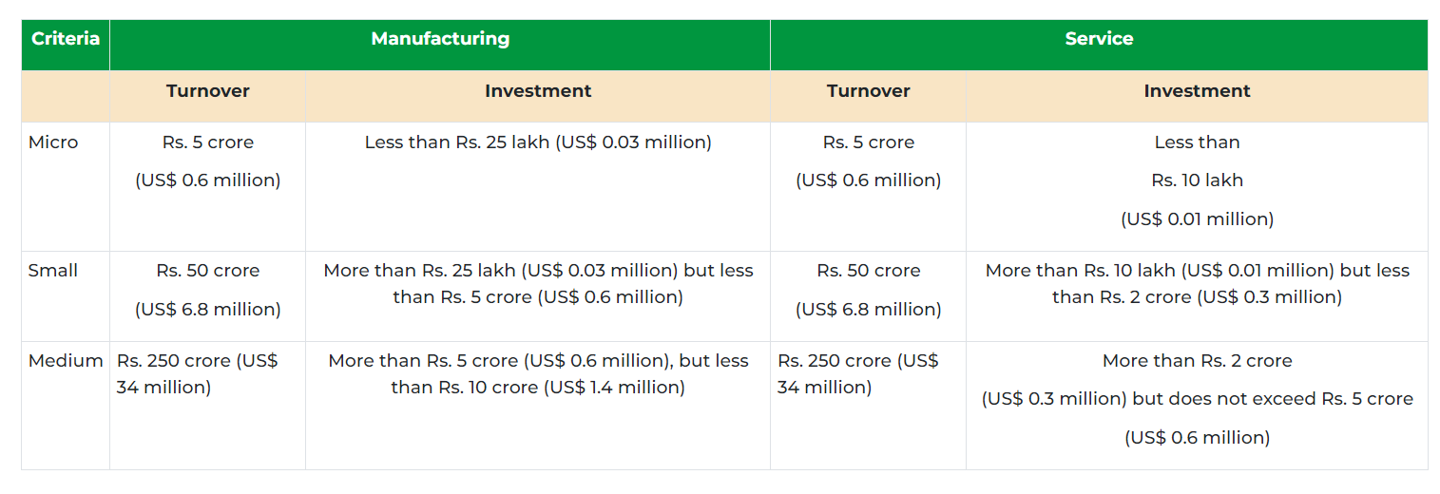

1. Significance of MSME in India:

The importance of the Micro, Small, and Medium Enterprises (MSMEs) sector lies in its substantial contribution to the country's socio-economic development. Specifically in India, this sector holds significant value due to its contributions to the Gross Domestic Product (GDP) and exports of the nation. Moreover, the MSME sector has played a pivotal role in fostering entrepreneurship, particularly in semi-urban and rural regions of India.

1. Micro, small, and medium enterprises (MSMEs) are widely acknowledged as the backbone of the Indian economy. These enterprises not only contribute to nearly 30% of India's GDP as of FY2023 but also play a crucial role as catalysts for employment generation, exports, and the credit market in the country. Furthermore, the MSME sector serves to mitigate regional imbalances by serving as a major employer in rural and less-developed areas of the nation.
2. However, despite being the growth engine of the economy, the MSME sector faces significant challenges on various fronts. These challenges include a lack of timely financial assistance, technological obsolescence, expensive power supply, and formidable competition from global counterparts.
3. As of February 2023, the Indian government's Udyam registration portal had registered nearly 13.8 million micro-enterprises, making up an impressive 96 percent of the entire MSME sector. Meanwhile, small enterprises constituted around three percent, and medium enterprises comprised 0.28 percent of the registered entities. Overall, the platform had successfully recorded registrations from over 14 million MSMEs.
4. Form more than 95% of the industries in India.Produce more than 45% of the total manufacturing output.Employ more than 40% of the workforce
5. The MSME sector demonstrated remarkable resilience in coping with challenges like demonetization, the implementation of Goods and Services Tax (GST), and the pandemic. Furthermore, it is actively striving to embrace current trends to ensure sustainable growth. Particularly, during and after the pandemic, the sector experienced significant transformations, driven by the expansion of neo-banks and digital payment platforms, which facilitated a wider client base, smoother transactions, and reduced reliance on manual labor.
6. Notably, Indian Micro, Small, and Medium Enterprises (MSMEs) are swiftly transitioning from cash transactions to digital payments, with approximately 72% of payments now being conducted through digital means, while cash transactions account for only 28%. This surge in digital adoption opens up promising opportunities for further expansion and development within the sector.
7. Market Size of MSMEs in India: According to data released by the Ministry of Micro, Small & Medium Enterprises, as of February 22, 2023, the Udyam Registration portal successfully recorded a total of 14,392,652 MSMEs, replacing the previous Udyog Aadhaar Memorandum (UAM) filing process. Among the registered entities, micro-enterprises accounted for the highest number, totaling 13,834,411 (96.12%), followed by small enterprises with 446,980 registrations (3.11%), and medium-sized enterprises with 40,400 registrations (0.28%).
8. Export potential of MSME in India:In the financial year 2023, the proportion of MSME-related exports in India constituted approximately 42.6 percent of the total exports. However, this figure experienced a decline compared to the financial years 2020 and 2021 when it accounted for around 49 percent of the total exports.
9. Average loan size of MSMEs in India:During the second quarter of the financial year 2023, medium-sized enterprises under the MSME category in India obtained the highest average loan size, amounting to 9.74 million Indian rupees. Additionally, during the same time period, small enterprises in the country secured the highest average loan size, approximately 4.5 million rupees.
10. Disbursement amounts in MSMEs in India:In the second quarter of the financial year 2023, the total disbursement amount in the Medium, Small, and Micro Enterprises (MSME) segment in India exceeded two trillion Indian rupees. Within this segment, small enterprises received a disbursement amount of 770 billion rupees during the same period.

## **1.2 Objective of the Study**

The primary objective of this case study is to elucidate the manifold advantages of Smart Manufacturing for Indian MSMEs. By showcasing the positive impact and potential growth opportunities, we aim to persuade business owners and stakeholders to embrace this transformative approach. Additionally, the study serves as a guide, outlining the steps and strategies for successful implementation. We aim to equip MSMEs with actionable insights, empowering them to make informed decisions and optimize their operations for sustainable growth.

## **1.3 Overview of Smart Manufacturing and its significance for MSMEs in India.**

Smart Manufacturing is the key to achieve the fourth Industrial Revolution ‘Industry 4.0’ that has the motive to fully automate the current manufacturing industries with the help of Technologies such as Cyber-Physical systems (CPS) , Internet of things (IoT) etc, In order to achieve Interoperability, Robustness Real-time controllability, Sustainability, Resilience, Transparency, Predictability, Efficiency and much more.

By embracing Smart Manufacturing, industries in India can undergo a revolutionary transformation into Industry 4.0, enabling them to compete effectively in the global market. In April 2023, the manufacturing production in India saw a significant increase of 4.90 percent compared to the same month in the previous year. Furthermore, the Value Added in Manufacturing market is projected to reach a substantial amount of US$244.50 billion in 2023, with an expected annual growth rate of 8.36% (CAGR 2023-2028). The Industry 4.0 Market size is forecasted to experience remarkable growth, expanding from USD 94.42 billion in 2023 to USD 241.58 billion by 2028, at an impressive CAGR of 20.67% during the forecast period (2023-2028). Manufacturing production, which contributes to 78 percent of total industrial output in India, encompasses various segments, including basic metals, coke and refined petroleum products, chemicals, food products, pharmaceuticals, motor vehicles, machinery, and textiles, among others. Thus adoption of Smart Manufacturing in these sectors can further drive efficiency, innovation, and competitiveness in the Indian manufacturing landscape and MSMEs

(Topic: MSMEs in India, 2023)  
(MSME Industry in India – Market Share, Reports, Growth & Scope | IBEF, n.d.)  
(Average Loan Size of MSMEs India Q4 FY 2020-Q2 FY 2023, by Segment, 2023)  
 (Disbursement Amounts in MSMEs India Q4 FY 2020-FY 2023, by Segment, 2023)  
(MSME Industry in India – Market Share, Reports, Growth & Scope | IBEF, n.d.)

# **2. Advantages and benefits of adopting smart manufacturing technologies for MSMEs**

## **2.1 Benefits and Advantages for Adopting Smart Manufacturing for MSMEs** Table 2.1 | techonologies and their role in MSMes

| **S.No** | **Technologies** | **Role of Technologies Helping MSMEs** |
| --- | --- | --- |
| **1.** | **Artificial Intelligence (AI) and Machine Learning (ML)** | 1. **Automating Routine Tasks**: AI and ML can automate repetitive tasks that consume valuable time and resources. By delegating these tasks to intelligent systems, MSMEs can free up their workforce to focus on more strategic and creative endeavors, ultimately improving overall productivity. 2. **Improved Efficiency and Productivity:** AI and ML can automate repetitive tasks and optimize processes, leading to increased efficiency and productivity. MSMEs can use AI-powered tools to streamline operations, manage inventory, and optimize production schedules, thus saving time and reducing costs. 3. **Demand Forecasting:** Predicting customer demand is crucial for MSMEs to optimize inventory and production. AI and ML algorithms can analyze historical sales data, market trends, and other relevant factors to provide accurate demand forecasts, minimizing inventory costs and ensuring products are available when needed. 4. **Data-Driven Decision Making:** MSMEs generate vast amounts of data, but without proper analysis, it remains underutilized. AI and ML algorithms can process and interpret this data, extracting valuable insights and patterns. These data-driven insights enable MSMEs to make informed decisions, spot emerging trends, and identify new business opportunities. 5. **Financial Management:** AI can assist MSMEs in managing their finances more effectively. It can automate bookkeeping processes, track expenses, and even analyze financial data to provide insights into cost-saving measures or investment opportunities. 6. **Enhancing Customer Experience**: AI-powered chatbots and customer support systems can deliver personalized and round-the-clock assistance to customers. By understanding customer preferences and behavior, MSMEs can offer tailored recommendations, leading to increased customer satisfaction and loyalty. 7. **Efficient Inventory Management:** AI and ML algorithms can analyze historical sales data, market trends, and seasonal variations to forecast demand accurately. This optimization of inventory management ensures that MSMEs maintain sufficient stock levels, avoiding excess inventory costs or stockouts. 8. **Streamlining Supply Chain**: AI-driven analytics can optimize supply chain logistics by identifying the most efficient routes, minimizing transportation costs, and reducing delivery lead times. This ensures smooth operations and enhances overall supply chain efficiency. 9. **Fraud Detection and Security:** AI-powered systems can continuously monitor financial transactions, detecting irregularities and potential fraud in real-time. This robust security measure safeguards MSMEs against financial losses and protects sensitive customer information. 10. **Access to Credit**: Many MSMEs struggle to access credit due to inadequate credit histories. AI-based credit scoring models can evaluate alternative data sources and assess creditworthiness more accurately, potentially improving MSMEs' access to much-needed funds. 11. **Product and Service Innovation:** AI and ML can help MSMEs gain insights into customer preferences and market demands. Armed with this knowledge, they can develop innovative products and services that better cater to their target audience. 12. **Employee Training and Skill Development:** AI-powered e-learning platforms can provide personalized training programs to employees, enabling MSMEs to upskill their workforce efficiently and keep pace with evolving industry trends. 13. **Market Intelligence and Competitor Analysis**: AI-driven market monitoring tools can track competitors' activities, market trends, and customer feedback. Armed with this intelligence, MSMEs can identify potential threats and opportunities, positioning themselves strategically in the market. |
| **2.** | **Internet of Things (IOT)** | 1. **Enhanced Operational Efficiency**: IoT devices can monitor and collect real-time data from various aspects of MSMEs' operations, including production processes, inventory management, and equipment performance. By analyzing this data, MSMEs can identify inefficiencies, streamline workflows, and optimize resource utilization, leading to increased operational efficiency and cost savings. 2. **Remote Monitoring and Maintenance**: IoT-enabled sensors and devices allow MSMEs to remotely monitor the condition of their assets and equipment. This capability enables predictive maintenance, as potential issues can be detected early, preventing costly breakdowns and reducing downtime. 3. **Improved Product Quality:** IoT facilitates continuous monitoring and data analysis during the manufacturing process. This ensures that product quality remains consistent and deviations are detected promptly, resulting in higher customer satisfaction and reduced product returns. 4. **Real-Time Inventory Management:** IoT-powered inventory tracking systems provide real-time visibility into stock levels and movement. MSMEs can automate inventory replenishment, optimize storage, and minimize stockouts, leading to efficient inventory management and reduced carrying costs. 5. **Supply Chain Optimization: I**oT can optimize the supply chain by providing valuable data on the location and condition of goods during transportation. MSMEs can leverage this information to choose the most efficient routes, ensure timely deliveries, and enhance collaboration with suppliers and logistics partners. 6. **Energy Efficiency:** IoT devices can monitor energy consumption within MSMEs' facilities. By identifying energy-intensive processes and areas of wastage, MSMEs can implement energy-saving measures, reducing operational costs and their environmental footprint. 7. **Customer Insights and Personalization**: IoT-enabled products and devices can collect data on customer usage patterns and preferences. This data helps MSMEs understand their customers better, enabling personalized offerings and targeted marketing strategies. 8. **Health and Safety Monitoring:** IoT sensors can enhance workplace safety by monitoring environmental conditions and ensuring compliance with safety protocols. MSMEs can proactively address potential hazards, leading to a safer work environment and reduced accident risks. 9. **Waste Management**: IoT solutions can optimize waste management processes by monitoring waste levels and collection schedules. This results in efficient waste disposal, reduced environmental impact, and potential cost savings. 10. **Competitive Advantage:** Embracing IoT can give MSMEs a competitive edge by enabling them to adopt innovative technologies and provide value-added services. It positions them as forward-thinking and customer-centric businesses in the market. |
| **3.** | **Augmented Reality (AR) and Virtual Reality (VR)** | 1. **Enhanced Product Visualization**: AR and VR technologies enable MSMEs to showcase their products in immersive and interactive ways. Customers can visualize and experience products virtually, allowing for a better understanding of features, functionalities, and design. This enhanced product visualization can lead to increased customer engagement and higher sales conversion rates. 2. **Virtual Showrooms and Tours:** MSMEs can create virtual showrooms and give customers virtual tours of their facilities or stores. This approach expands their reach beyond physical locations, attracting customers from different regions and enhancing the overall customer experience. 3. **Virtual Training and Skill Development:** AR and VR can be utilized to provide virtual training and skill development programs for MSME employees. This immersive learning experience can be more engaging and effective than traditional methods, helping employees acquire new skills and knowledge to improve their performance. 4. **Prototyping and Design Validation:** AR and VR technologies enable MSMEs to create virtual prototypes of products or designs. This facilitates design validation and allows for early detection of potential issues, reducing development costs and speeding up the product development cycle. 5. **Remote Collaboration and Communication**: AR and VR can facilitate remote collaboration among team members, suppliers, and clients. MSMEs can conduct virtual meetings, workshops, and presentations, eliminating the need for physical presence and saving time and travel expenses. 6. **Virtual Marketing Campaigns**: AR and VR can be integrated into marketing campaigns to create interactive and memorable experiences for customers. This innovative approach can generate buzz around MSME products or services, attracting more attention and potential customers. 7. **Customer Support and After-Sales Service**: AR and VR can assist in providing remote customer support and after-sales service. MSMEs can guide customers through troubleshooting processes or repairs using AR-guided instructions, leading to faster issue resolution and improved customer satisfaction. 8. **Trade Shows and Exhibitions:** Participating in trade shows and exhibitions can be expensive for MSMEs. VR technology offers a cost-effective alternative, allowing them to showcase their products virtually at such events, thereby increasing visibility and reaching a broader audience. 9. **Safety Training and Hazard Simulation:** AR and VR can be employed to simulate hazardous environments for safety training purposes. MSMEs operating in high-risk industries can use these technologies to train employees in a safe and controlled virtual environment, minimizing real-world risks. 10. **Market Research and Consumer Insights:** AR and VR can facilitate market research by creating virtual focus groups or conducting simulated consumer behavior studies. This data can provide valuable insights for MSMEs in understanding customer preferences and refining their products or services. |
| **4.** | **Digital Twins** | 1. **Real-Time Monitoring and Analysis:** Digital twin technology creates virtual replicas of physical assets and processes. MSMEs can use these digital twins to monitor real-world operations in real-time, enabling them to identify performance issues, detect anomalies, and make data-driven decisions promptly. 2. **Predictive Maintenance:** By analyzing data from digital twins, MSMEs can predict equipment failures and maintenance needs accurately. This predictive maintenance approach reduces downtime, minimizes maintenance costs, and extends the lifespan of critical machinery and assets. 3. **Product Development and Testing:** Digital twins facilitate virtual prototyping and testing of products before physical production. MSMEs can experiment with different designs, materials, and configurations, leading to faster development cycles and reduced development costs. 4. **Process Optimization**: Digital twins provide insights into process inefficiencies and bottlenecks. MSMEs can simulate process variations and optimize workflows to achieve higher productivity and resource utilization. 5. **Resource Management**: Digital twins help MSMEs in managing resources effectively. Whether it's tracking raw materials, energy consumption, or manpower allocation, digital twins offer valuable data for efficient resource management. 6. **Quality Control and Assurance:** MSMEs can use digital twins to monitor and ensure product quality consistency. By comparing real-world performance with virtual simulations, they can identify deviations and take corrective actions early in the production process. 7. **Supply Chain Visibility**: Digital twins enable better visibility into supply chain operations. MSMEs can track the movement of goods, monitor inventory levels, and optimize logistics processes, leading to streamlined supply chain management. 8. **Training and Skill Development:** Digital twins provide a safe environment for training employees. MSMEs can use virtual replicas to simulate complex tasks, train workers on new equipment, and enhance their skills without the risk of real-world accidents or damages. 9. **Remote Collaboration and Troubleshooting:** Digital twins facilitate remote collaboration among teams and experts. MSMEs can use this technology to troubleshoot issues, receive guidance, and collaborate with specialists, regardless of geographical barriers. 10. **Competitive Advantage**: Embracing digital twin technology sets MSMEs apart as innovative and forward-thinking businesses. The ability to leverage digital twins for process optimization, predictive maintenance, and agile product development gives MSMEs a competitive edge in the market. |
| **5.** | **Robotics and Automation** | 1. **Robotics and automation** offer significant benefits to Micro, Small, and Medium Enterprises (MSMEs) in India, enabling them to boost productivity, reduce costs, and enhance competitiveness. 2. **Increased Efficiency and Productivity**: By automating repetitive and labor-intensive tasks, robotics and automation can significantly increase the efficiency of MSMEs' operations. This allows employees to focus on more strategic and value-added activities, leading to improved overall productivity. 3. **Consistent Quality and Precision:** Automation ensures consistency and precision in manufacturing processes. By reducing human errors, MSMEs can deliver products with higher quality, resulting in increased customer satisfaction and loyalty. 4. **Cost Reduction:** Robotics and automation can lead to cost savings in the long run. Once initial setup costs are covered, the reduced need for manual labor and decreased error rates translate into lower operational expenses. 5. **Flexible Manufacturing:** Collaborative robots, also known as cobots, can work alongside human workers, providing flexibility in manufacturing processes. MSMEs can easily adapt to changes in demand and product variations without requiring extensive reconfiguration. 6. **24/7 Operations:** Automated systems can operate round-the-clock without breaks, significantly increasing production output and meeting tight deadlines, especially during peak demand periods. 7. **Enhanced Workplace Safety**: Robots can handle hazardous and dangerous tasks, ensuring the safety of human workers. By reducing the risk of workplace accidents, MSMEs can create a safer work environment and minimize the associated costs and legal liabilities. 8. **Data Collection and Analysis:** Automation enables the collection of real-time data from various processes. This data can be analyzed to gain valuable insights into production efficiency, identify areas for improvement, and make data-driven decisions. 9. **Customization and Personalization: A**utomation can be utilized for customized production, allowing MSMEs to offer personalized products to their customers. This flexibility enhances customer satisfaction and meets diverse market demands. 10. **Supply Chain Optimization:** Robotics and automation can be integrated into the supply chain, streamlining warehousing, order fulfillment, and logistics processes. This optimization ensures smoother operations, quicker deliveries, and better inventory management. 11. **Competitive Edge:** Embracing robotics and automation gives MSMEs a competitive advantage. By adopting innovative technologies, MSMEs can position themselves as industry leaders, attracting more customers and forging stronger partnerships. |
| **6.** | **Additive Manufacturing** | 1. **Cost-Effective Prototyping**: Additive Manufacturing allows MSMEs to create rapid prototypes with reduced costs and lead times. This enables them to iterate and refine product designs more efficiently, accelerating the product development cycle. 2. **Customization and Personalization**: MSMEs can use Additive Manufacturing to produce customized products, catering to individual customer preferences. This ability to offer personalized products can lead to higher customer satisfaction and increased market demand. 3. **Reduced Material Waste:** Additive Manufacturing is an additive process, where material is added layer by layer to create the final product. This results in minimal material wastage, making it an eco-friendly and cost-effective production method for MSMEs. 4. **Complex Geometries and Lightweight Designs**: Additive Manufacturing allows MSMEs to create complex and intricate designs that may be difficult or impossible to achieve through traditional manufacturing methods. Additionally, it enables the production of lightweight components, ideal for industries such as aerospace and automotive. 5. **On-Demand Manufacturing:** With Additive Manufacturing, MSMEs can produce items on-demand, reducing the need for large inventories and warehouse space. This just-in-time production approach minimizes inventory costs and ensures better inventory management. 6. **Supply Chain Flexibility**: Additive Manufacturing enables local production of parts and components, reducing the dependency on global supply chains. This enhances supply chain resilience and mitigates risks associated with disruptions in international trade. 7. **Tooling and Jigs** Production: MSMEs can use Additive Manufacturing to produce custom tools, jigs, and fixtures, improving the efficiency of manufacturing processes. These tailored tools enable faster production and reduce human error. 8. **Low-Volume Production**: For low-volume production runs, Additive Manufacturing can be more cost-effective than traditional methods. MSMEs can produce small batches of products without the need for expensive tooling and setup. 9. **Innovation and Research**: Additive Manufacturing encourages innovation and experimentation within MSMEs. It allows them to explore new design possibilities and test novel concepts, leading to the development of unique products and services. 10. **Accessibility and Localization:** Additive Manufacturing technology is becoming more accessible and affordable. This democratization of the technology allows smaller MSMEs to adopt Additive Manufacturing solutions, promoting localized production and boosting regional economies. |
| **7.** | **Cloud and Edge Computing** | 1. **Cost Savings:** Cloud computing allows MSMEs to access computing resources on a pay-as-you-go basis, eliminating the need for upfront infrastructure investment. This cost-effective approach reduces capital expenditures and operational costs, making it more affordable for MSMEs to adopt advanced technologies. 2. **Scalability and Flexibility:** Cloud computing offers scalable resources that can be adjusted based on fluctuating demands. MSMEs can easily scale up or down their computing power, storage, and applications, providing them with the agility to respond to market changes swiftly. 3. **Remote Collaboration and Accessibility:** Cloud computing enables seamless remote collaboration among employees, customers, and partners. MSMEs can access critical business data and applications from anywhere, facilitating remote work and improving overall productivity. 4. **Data Backup and Disaster Recovery**: Cloud computing provides robust data backup and disaster recovery solutions. MSMEs can ensure the safety of their valuable data by storing it in multiple locations, protecting them from data loss due to hardware failures or natural disasters. 5. **Enhanced Security:** Cloud service providers employ advanced security measures to protect data and applications. This level of security expertise may exceed what MSMEs can implement independently, providing them with a more secure IT environment. 6. **Edge Computing for Real-Time Processing**: Edge computing brings computation and data storage closer to the point of data generation. This is particularly beneficial for MSMEs in industries requiring real-time data processing, such as manufacturing, logistics, and IoT-based applications. 7. **Reduced Latency:** Edge computing reduces the latency associated with data transmission to and from centralized cloud servers. This is critical for applications that demand low latency, ensuring a seamless user experience. 8. **Bandwidth Optimization:** Edge computing reduces the need for sending large volumes of data to the cloud for processing. Instead, data is processed locally at the edge, optimizing bandwidth usage and reducing costs for MSMEs. 9. **IoT Integration**: Both cloud computing and edge computing play crucial roles in enabling Internet of Things (IoT) applications. MSMEs can leverage these technologies to manage and analyze data from IoT devices efficiently. 10. **Competitive Advantage:** Adopting cloud computing and edge computing gives MSMEs a competitive edge. These technologies empower MSMEs to be more agile, innovative, and responsive to market demands, positioning them as tech-savvy and forward-thinking enterprises. |
| **8.** | **Big data Analytics** | 1. **Data-Driven Decision Making:** Big data analytics allows MSMEs to analyze large volumes of structured and unstructured data to gain valuable insights. By basing decisions on data-driven evidence rather than intuition, MSMEs can make more informed and effective choices, leading to better business outcomes. 2. **Understanding Customer Behavior:** Big data analytics can analyze customer data, such as purchase history, preferences, and interactions, to understand customer behavior better. This knowledge helps MSMEs tailor their products and services to meet customer needs, increasing customer satisfaction and loyalty. 3. **Market Analysis and Trends**: MSMEs can use big data analytics to analyze market trends, competitor activities, and consumer sentiment. This information provides MSMEs with a deeper understanding of the market landscape, enabling them to identify opportunities and stay ahead of the competition. 4. **Operational Efficiency:** Big data analytics can optimize MSMEs' internal processes and workflows. By analyzing operational data, MSMEs can identify inefficiencies and bottlenecks, leading to streamlined operations and cost savings. 5. **Personalized Marketing:** Big data analytics enables MSMEs to deliver personalized marketing campaigns to individual customers. By tailoring marketing messages based on customer preferences and behavior, MSMEs can increase the effectiveness of their marketing efforts. 6. **Risk Management**: Big data analytics can assist MSMEs in identifying potential risks and vulnerabilities in their business operations. By analyzing data, MSMEs can proactively address risks and implement risk management strategies. 7. **Supply Chain** Optimization: MSMEs can use big data analytics to optimize their supply chain processes. By analyzing supply chain data, MSMEs can improve inventory management, reduce lead times, and enhance overall supply chain efficiency. 8. **Financial Analysis and Planning**: Big data analytics can help MSMEs in financial analysis and forecasting. By analyzing financial data, MSMEs can make informed financial decisions and plan for the future effectively. 9. **Product and Service Innovation:** MSMEs can leverage big data analytics to identify gaps in the market and opportunities for innovation. By analyzing customer feedback and market trends, MSMEs can develop new products and services that address customer needs. 10. **Competitive Advantage**: Adopting big data analytics gives MSMEs a competitive advantage. By harnessing the power of data, MSMEs can improve their decision-making, operational efficiency, and customer experiences, positioning themselves as innovative and forward-thinking businesses. |
| **9.** | **Cyber Security** | 1. **Protection Against Cyber** Threats: Cybersecurity measures such as firewalls, antivirus software, and intrusion detection systems can shield MSMEs from various cyber threats like malware, ransomware, and phishing attacks. These defenses help prevent unauthorized access to systems and data breaches. 2. **Data Protection and Privacy Compliance:** MSMEs often handle sensitive customer and business data. Cybersecurity safeguards ensure that this data remains secure and is not compromised. Complying with data protection regulations enhances customer trust and avoids legal repercussions. 3. **Preventing Financial Losses:** Cybersecurity measures mitigate the risk of financial losses resulting from cyberattacks. Such attacks can lead to financial theft, fraudulent activities, or disruption of online payment processes. By protecting their digital assets, MSMEs can avoid significant financial setbacks. 4. **Business Continuity and Disaster Recovery:** Implementing cybersecurity measures also involves creating comprehensive disaster recovery plans. These plans enable MSMEs to quickly recover from cyber incidents and resume normal business operations, minimizing downtime and associated losses. 5. **Preserving Business Reputation**: A cyber incident can severely damage an MSME's reputation, leading to loss of customer trust and credibility. Robust cybersecurity practices protect against data breaches and ensure the integrity of customer data, maintaining a positive image in the market. 6. **Safe Adoption of New Technologies**: As MSMEs adopt new technologies like cloud computing and IoT, cybersecurity becomes critical. Proactive security measures enable safe integration of these technologies into business processes, avoiding potential vulnerabilities. 7. **Training and Awareness Programs**: Educating employees about cybersecurity best practices is essential for MSMEs. Training programs raise awareness about common cyber threats and teach employees how to identify and respond to potential risks effectively. 8. **Cyber Insurance**: Cybersecurity measures can also facilitate obtaining cyber insurance coverage. Cyber insurance provides financial protection in the event of a cyber incident, helping MSMEs recover from potential financial losses. 9. **Supply Chain Security:** Cybersecurity is not limited to individual MSMEs but also extends to their supply chain partners. Implementing cybersecurity standards throughout the supply chain ensures that vulnerabilities in one entity do not compromise the entire ecosystem. 10. **Competitive Advantage**: Emphasizing a strong cybersecurity posture can give MSMEs a competitive advantage. Customers and partners are more likely to trust businesses that prioritize security, leading to increased business opportunities and partnerships. |

## **2.2 Current Challenges faced by MSMEs in adoption of Smart manufacturing technologies India**

1. **Technological Constraint**: Difficulty to select the most appropriate and cost-effective technologies for their specific needs.
2. **Return on Investment (ROI) Uncertainty**: MSMEs are cautious about investing in smart manufacturing technologies due to uncertainty about the ROI and the time required to realize the benefits. Convincing stakeholders about the long-term advantages can be challenging.
3. **Resistance to Change**: Traditional mindsets and resistance to organizational change can hinder the adoption of smart manufacturing technologies. Employees may fear job displacement or lack the motivation to embrace technological advancements.
4. **Government Support and Policies:** While the Indian government has introduced initiatives to promote digital transformation and smart manufacturing, MSMEs may still face difficulties in accessing relevant support and navigating complex policies.

## **2.3 Importance of Collaboration Between MSMEs with Academia or Research Departments**

Collaboration between Micro, Small, and Medium Enterprises (MSMEs) and academic or research institutions can be mutually beneficial and play a crucial role in driving technological advancements. There are many Institutes offering Smart Manufacturing Discipline for promoting Smart Manufacturing such as IIITDM Jabalpur, IIITDM Kancheepuram , Some institutes are integrated with Smart Factories to show the prototype of a Smart Factory Layout so that Industries can convert into Smart Factories such as IISC Bangalore and IIT Delhi Smart Factory and also several Research and Development Platforms.

Here are some ways in which such collaboration can help both parties and foster technological progress:

1. **Access to Research and Knowledge:** Academic and research institutions are centers of expertise and knowledge. By collaborating with these institutions, MSMEs gain access to cutting-edge research, the latest technological trends, and valuable insights that can be applied to their business operations.
2. **Technology Transfer**: Academic institutions often develop innovative technologies and prototypes. Through collaboration, MSMEs can access these technologies and explore possibilities for their commercialization and implementation in practical applications.
3. **Skilled Workforce Development**: Collaboration with academic institutions enables MSMEs to engage with students and researchers. By participating in projects or providing internships and training opportunities, MSMEs can contribute to the development of a skilled workforce while also identifying potential future employees.
4. **Research and Development (R&D) Support:** MSMEs typically have limited R&D capabilities due to resource constraints. By partnering with research institutions, they can leverage the institution's R&D infrastructure, facilities, and expertise to conduct innovative research and development projects.
5. **Joint Projects and Innovation:** Collaborative projects between MSMEs and academic institutions can lead to innovative solutions and product developments that address real-world challenges. The diverse perspectives and expertise of both parties often result in novel approaches to problem-solving.
6. **Validation and Credibility:** Research findings and technological advancements coming from academic institutions carry a level of credibility and validation. Partnering with these institutions can enhance the reputation and credibility of the MSMEs, especially when presenting their products or services to potential customers and investors.
7. **Access to Funding Opportunities**: Academic and research institutions often receive grants and funding for specific projects. MSMEs collaborating on such projects can gain access to additional funding sources, reducing the financial burden of technological advancements.
8. **Network Expansion:** Collaboration with academic institutions provides MSMEs with an opportunity to expand their professional network. This exposure can lead to new partnerships, business opportunities, and access to a broader market.
9. **Testbeds and Prototyping:** Many academic institutions have well-equipped laboratories and facilities suitable for testing and prototyping new technologies. MSMEs can utilize these testbeds to validate and refine their innovations before full-scale implementation.
10. **Addressing Societal Challenges:** Collaborative efforts can focus on addressing societal challenges, such as sustainability, environmental issues, and healthcare. By aligning their technological advancements with social needs, MSMEs can have a more significant positive impact.

# **3.Case Study:**

## **3.1 Schneider ElectricSmart Factory:**

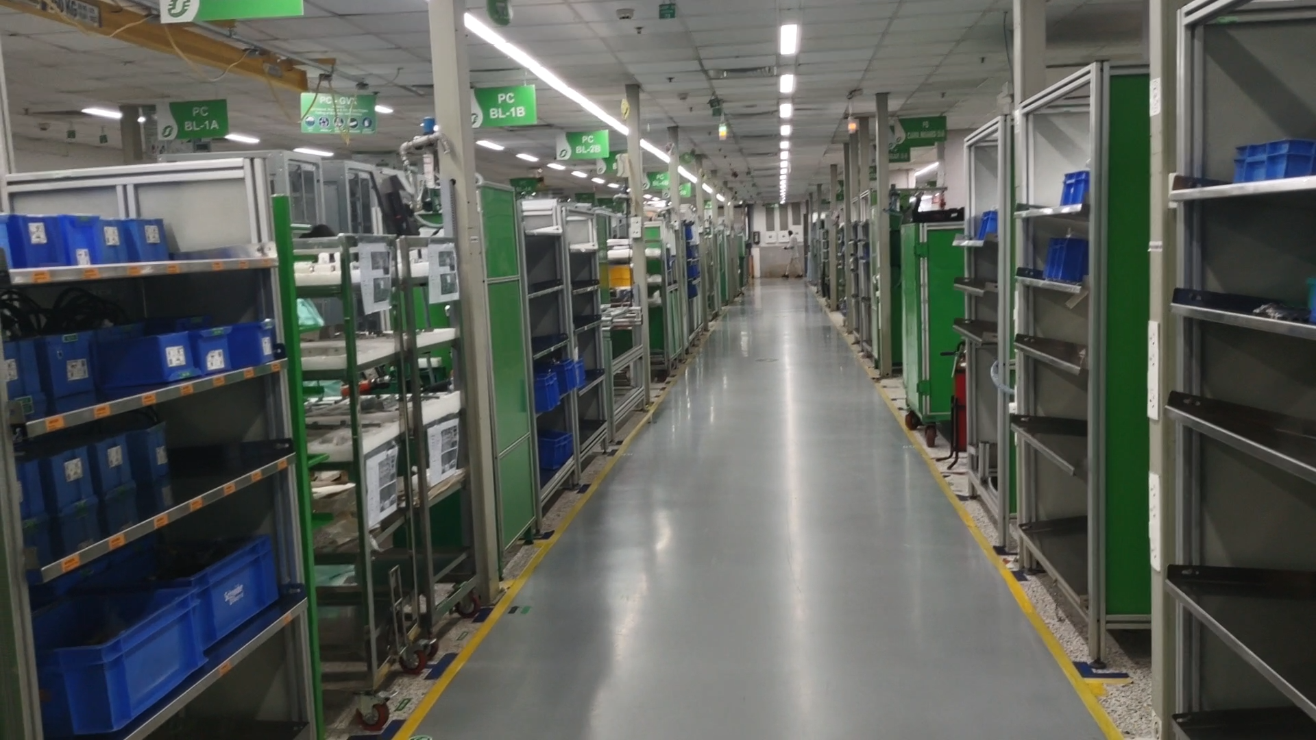

**Figure 3.1 | Schneider Electric IDF4 Bangalore showing inventory**

**Schneider Electric's Bengaluru Smart Factory** is a pioneering example of Industry 4.0 and smart manufacturing technologies. Embracing its vision of bridging progress and sustainability for all, Schneider Electric dedicated itself to revolutionizing its manufacturing operations worldwide. The Bengaluru Smart Factory, inaugurated as part of India's Industry 4.0 agenda, serves as a platform for customers to witness the advantages of industrial digital transformation. It aims to improve performance, reliability, safety, and sustainability by implementing cutting-edge smart manufacturing technologies.The Factory's primary focus lies in the production of **Uninterruptible Power Supply** (UPS) units and **Drives** in a sustainable manner.

**The Smart Factory Program** holds immense significance as a landmark project for the company. This program marks a remarkable milestone, and its flagship site in Batam, Indonesia, serves as a prominent showcase for this groundbreaking initiative. The factory was duly recognized in 2019 as a Fourth Industrial Revolution (4IR) Lighthouse by the World Economic Forum, highlighting its cutting-edge technological prowess. Furthermore, the Ministry of Industry of the Republic of Indonesia designated it as the first National Lighthouse, underscoring its role in exemplifying Industry 4.0 in the manufacturing sector.

The conception and design of this factory were rooted in a profound focus on seamlessly integrating digital technology within a Smart Supply Chain strategy. The primary objectives were to optimize efficiency, enhance customer service outcomes (including on-time delivery and supplier service rate), reduce operational costs, and demonstrate the substantial positive impact of digital tools on manufacturing performance. The Smart Factory Program indeed sets a new standard in the pursuit of excellence through innovative digital solutions and advanced manufacturing practices.

### **3.1.1 Implementation of Smart Manufacturing Technologies:**

The Schneider Smart Factory adopts a variety of smart manufacturing technologies to optimize its processes and ensure efficiency.Schneider Electric’s EcoStruxure is an open architecture and platform enables the implementation of Cyber physical system (CPS) more appropriately Cyber Physical Production Systems (CPPS) and Advanced Cyber-Physical Systems (ACPS): that lead the integration of physical systems (such as machines, equipment, and devices) with digital systems (such as sensors, software, and connectivity). These systems create a feedback loop where data is collected from physical assets, analyzed in real-time, and used to make autonomous or optimized decisions to improve manufacturing processes Ecostruxure ensures IoT-enabled, plug-and-play, open, interoperable architecture and platform, in Homes, Buildings, Data Centers, Infrastructure and Industries. Innovation at Every Level from Connected Products to Edge Control, and Apps, Analytics and Services.The Bengaluru Smart Factory demonstrates how the digitisation of industrial environments using EcoStruxure can optimize the processes for both production and end to end supply chain operation and take energy efficiency to a whole new level.

**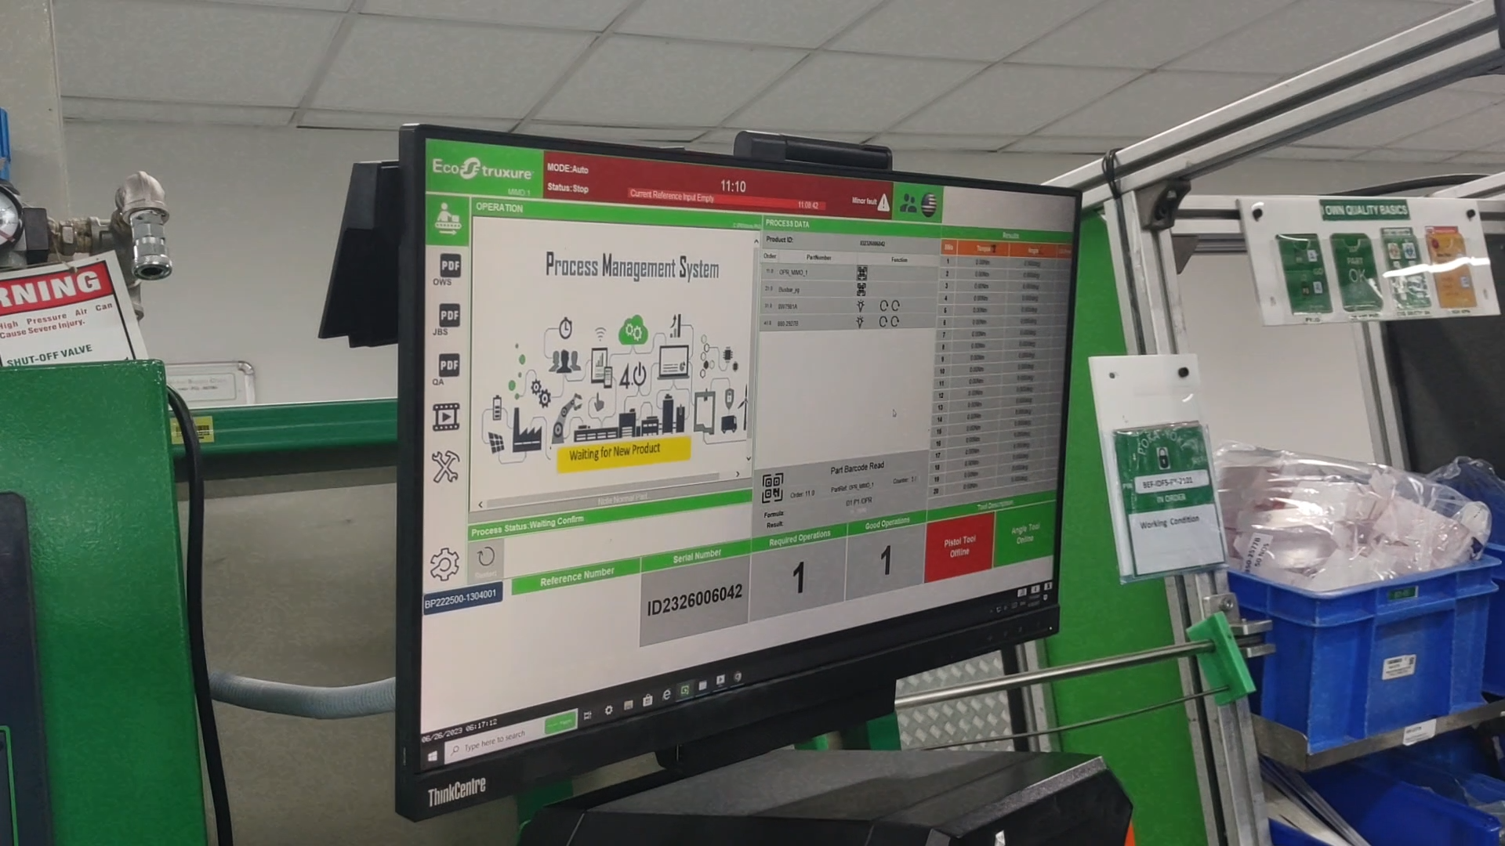  
Figure 3.2 | Schneider Electric IDF4 Bangalore showing data visualization and dashboards**

1. **Internet of Things (IoT)/Industrial Internet of Things (IIoT):** IoT devices and sensors are interconnected, collecting and sharing data for predictive maintenance, process optimization, and real-time monitoring.EcoStruxure-IOT provides a plug-and-play, open, and interoperable architecture and platform that spans across various domains such as Homes, Buildings, Data Centers, Infrastructure, and Industries. It fosters innovation at all levels, ranging from Connected Products to Edge Control and Apps, Analytics, and Services.IOT Monitoring & System Alert: The IOT Monitoring & System Alert is a cloud-connected monitoring and control system designed specifically for plants and machines. By utilizing this system, potential issues can be detected early on, generating predictive maintenance alerts. Consequently, service staff can be promptly dispatched to address these concerns before they escalate into failures.This comprehensive system offers real-time monitoring of machine performance and facilitates preventive maintenance, resulting in significantly improved agility and cost optimization.

**Benefits**

1. **Machine Andon:** Notifying management, maintenance, and other workers about any quality or process-related problems, enabling swift responses and solutions.
2. **Quality Statistical Process Control (SPC)**: Monitoring process behavior and identifying solutions for production issues, thereby ensuring better quality control.
3. **Predictive Maintenance:** Identifying potential equipment failures in advance, allowing for timely interventions and preventing costly breakdowns.

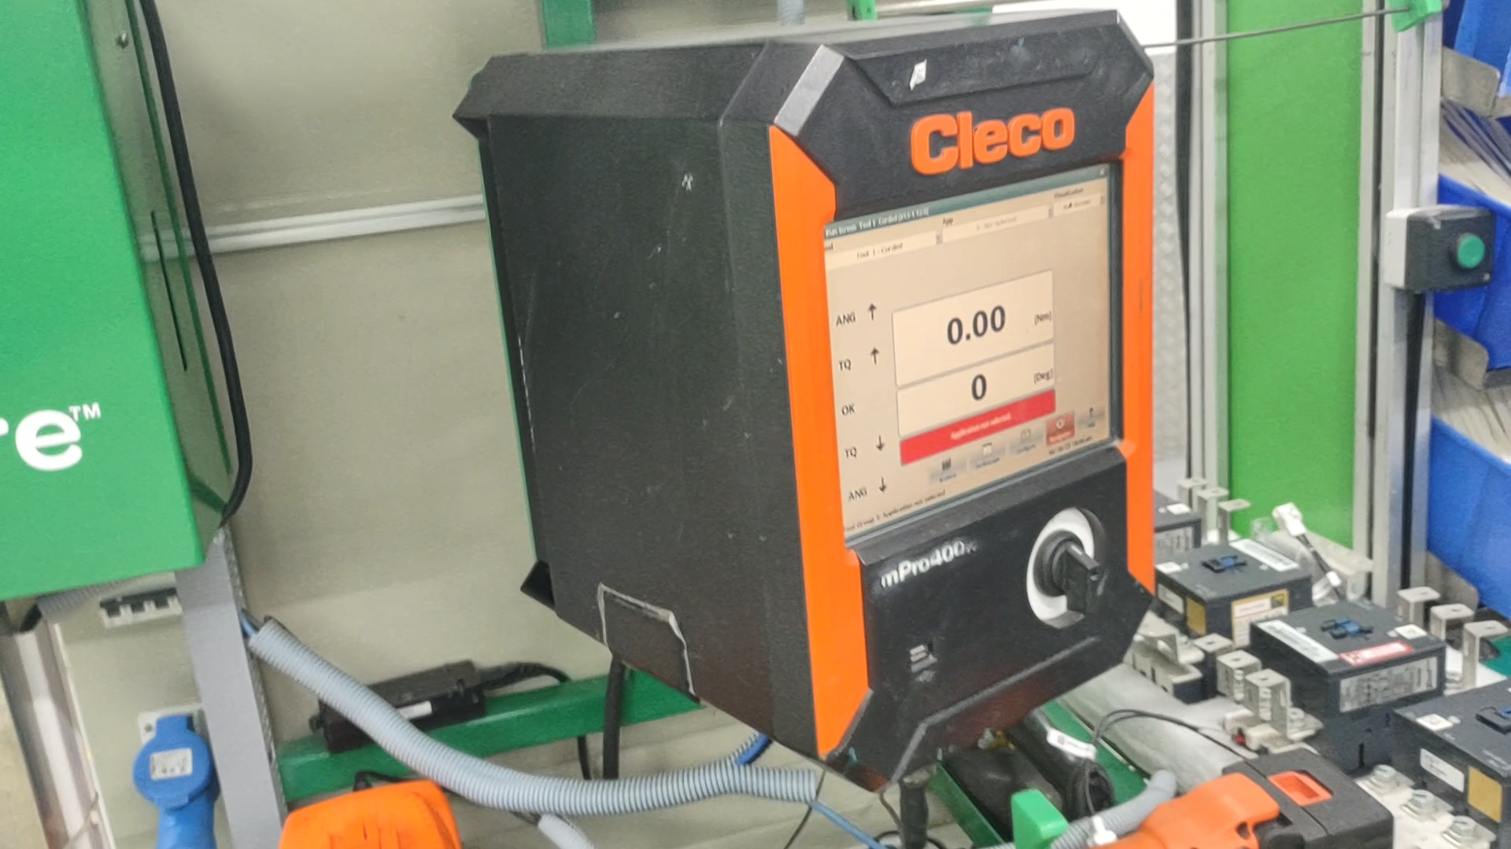

**Figure 3.3 | Schneider Electric IDF4 Bangalore showing torque gun operating parameters**

**B. Augmented Reality (AR)/Virtual Reality (VR)**:

AR and VR technologies are used for training, maintenance, and troubleshooting, enhancing the productivity of worker.

EcoStruxure™ Augmented Operator Advisor (AOA) is a tailor-made application designed to provide real-time information right at your fingertips, precisely when and where it's needed. This innovative tool grants immediate access to instant data diagnosis, user manuals, instructions, diagrams, and more, facilitating better operational efficiency through the power of augmented reality. With AOA, operators can superimpose current data and virtual objects onto machines or plants, gaining valuable visibility into operations and maintenance processes.The utilization of augmented reality empowers operators with crucial insights, ultimately leading to a remarkable 10% reduction in the mean time to repair critical equipment, streamlining maintenance operations and minimizing downtime.

**Benefits:**

1. **Improved Operations & Maintenance Efficiency:** AOA optimizes the efficiency of both operations and maintenance tasks, enhancing overall productivity.
2. **Reduced Operations & Maintenance Time & Cost:** By providing instant access to relevant information and facilitating streamlined processes, AOA effectively reduces both time and cost associated with operations and maintenance.
3. **Minimized Operator Errors during Maintenance Activity:** With AOA's guidance and real-time information, the likelihood of operator errors during maintenance activities is significantly reduced.
4. **Enhanced Support and Information Delivery:** AOA ensures operators have access to comprehensive and easily accessible support, resulting in more efficient information delivery and problem-solving.

**C. Additive Manufacturing:**

The integration of additive manufacturing in 3D printing technology has revolutionized the prototyping process for new products, empowering designers with unprecedented design capabilities. This cutting-edge technology enables the efficient production of a diverse range of prototypes, maintenance spare parts, jigs, fixtures, and assemblies, all customized to meet specific end-product requirements and designed in any desired shapes and configurations.

**Benefits :**

1. **Ensuring Quality Comparable to Original Parts:** Additive manufacturing produces parts of exceptional quality, on par with the original components, guaranteeing reliable and functional prototypes or spare parts.
2. **Accelerating Availability of Maintenance Spare Parts:** With 3D printing, the turnaround time for producing maintenance spare parts is significantly reduced, expediting the maintenance and repair processes.
3. **Facilitating Rapid Feedback for Prototypes:** 3D printing allows for swift iteration and modification of prototypes, enabling designers to receive faster feedback and make necessary improvements promptly.
4. **Providing Cost-Effective Alternatives for Specific Imports:** Additive manufacturing offers a cost-effective solution for creating specific spare parts and jigs that were previously imported, reducing expenses and enhancing supply chain efficiency.

**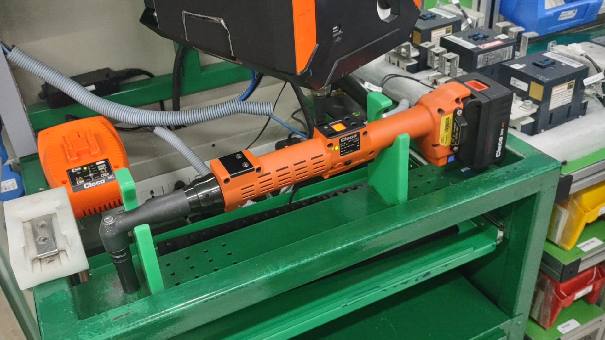  
Figure 3.4| Schneider Electric IDF4 Bangalore showing torque gun places on stand**

D. **Digital Twin**:

Virtual replicas of physical assets enable simulation, testing, and predictive maintenance, improving overall performance and reducing downtime.

Since The Shop floor i.e the production is on discrete assembly lines and not under continuous assembly lines as usually 10 units of UPS or drives are produced, there is no intense need of Digital twin systems.

**E. Artificial Intelligence (AI) and Machine Learning (ML):**

AI and ML algorithms analyze data patterns, providing predictive analytics and process optimization.Schneider Electric leverages its extensive manufacturing and domain expertise, complemented by cutting-edge innovations in AI, machine learning, and deep learning, to enable intelligent decision-making, increased agility, and progress in decarbonization efforts.The Virginia App represents a comprehensive ecosystem of interconnected tools designed to enhance sales efficiency through data-driven recommendations. By consolidating data from various Schneider Electric systems, the app monitors customer activities and delivers valuable business insights.The app enhances sales efficiency by prioritizing customers requiring more attention and providing actionable recommendations. Powered by AI, the sales assistant offers customized insights, including product recommendations, ordering patterns, and product decommissioning information.

**F. Robotics and Automation (including Drones/UAVs):**

Robotics automate repetitive tasks, improving precision, speed, and reducing errors.

Additionally, in the domain of material transportation, Schneider Electric employs Collaborative Robots (Cobots) and Automated Guided Vehicles (AGV Robots) to perform tasks efficiently and autonomously.

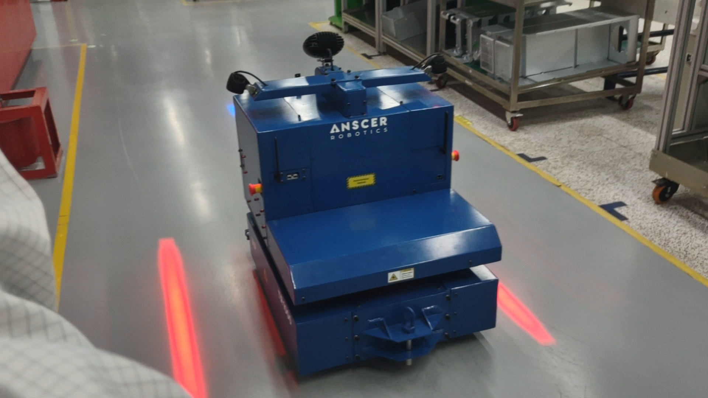

**Figure 3.4| Schneider Electric IDF4 Bangalore showing Agv (automated Guided Vehicle)**

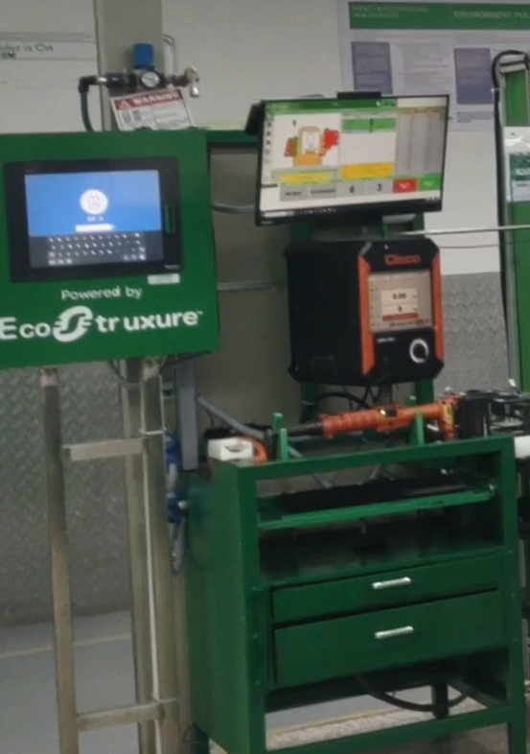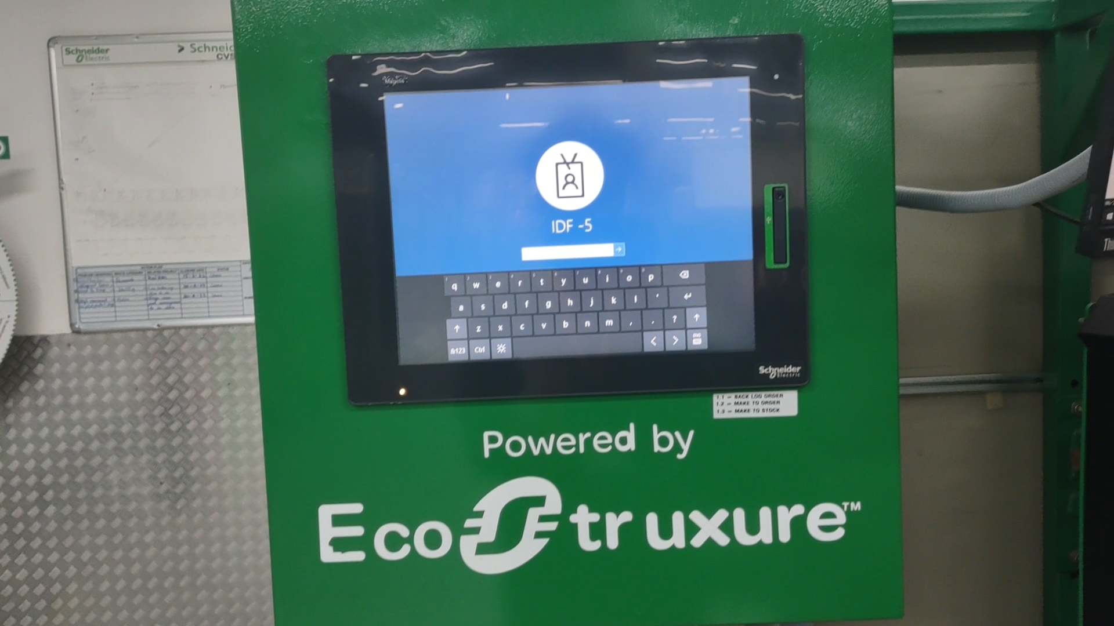  
**Figure 3.5| Schneider Electric IDF4 Bangalore showing operating systems software and hardware**  
**3.1.2 Analysis of Smart Manufacturing Systems and Processes:**

The Schneider Smart Factory adopts a process layout, with workstations and equipment grouped based on functions. It follows a job shop manufacturing process for assembly, allowing for customization and flexibility. The factory utilizes a worker-machine system with slight automation for specific tasks.Digitization and automation have led to increased efficiency and agility on the shop floor. The implementation of a smart supply chain strategy allows for better closed-loop measurement and controls, optimizing throughput and processing speed. Asset performance management ensures optimized asset use, improving profitability. Empowered operators make more effective decisions on the factory floor, contributing to enhanced reliability and uptime.

### 

### 

### **3.1.3 Impact of Smart Manufacturing:**

The adoption of smart manufacturing technologies has had a significant impact on production, cost, and product quality at the Schneider Smart Factory:

1. **Production Efficiency:** Smart manufacturing has streamlined production processes, resulting in reduced cycle times and increased output. Real-time monitoring and predictive maintenance minimize downtime.Up to 10% energy savings yearly through EcoStruxure Power solutions including EcoStruxure Power Monitoring Expert and EcoStruxure Resource Advisor
2. **Cost Reduction:** Automation and process optimization have led to cost savings in labor, energy consumption, and material waste. Improved efficiency translates to reduced operational costs.
3. **Product Quality:** Smart manufacturing technologies enable better quality control, reducing defects and enhancing product consistency. Real-time data analysis helps identify issues and implement corrective actions promptly.
4. **Sustainability**
5. Schneider Electric becomes one of the first corporates in the world to get the [Net-Zero targets](https://download.schneider-electric.com/files?p_Doc_Ref=SE-Net-Zero-Commitment&_ga=2.5071803.902758416.1675614380-885350088.1675200515) for its entire value chain validated by the Science Based Targets initiative
6. Schneider Electric’s solutions and services helped customers save and avoid 440 million tonnes of CO2 since 2018, with more than 90 million more in 2022 alone
7. On top of that, the company’s top suppliers reduced their own CO2 emissions by 10% through its [Zero Carbon project](https://www.se.com/ww/en/about-us/sustainability/zero-carbon-project.jsp), and the Group initiated supplier engagement to advance decent work standards in its supply chain
8. 45% of all packaging from the company is now made without single-use plastic and use recycled cardboard, up from 21% in 2021
9. The company also expanded access to green and reliable electricity to 5.5 million people through its solutions and projects in 2022
10. About 70,000 people benefited from its energy management training programs as well
11. Schneider Electric launched its Sustainability School for all employees, so everyone can really understand the Planet and People challenges and do more at work and also in their personal lives
12. Overall progress made to fight Climate change, improve Resource efficiency, reinforce Trust and Equal opportunities, and empower all Generations contributed to a full-year Sustainability Impact score of 4.91/10, well above the target of 4.70 for the year

### **3.1.4 Lessons Learned and Best Practices:**

1. Schneider Electric's journey towards establishing the Smart Factory offers valuable lessons and best practices for other MSMEs:
2. Invest in Technology Partnerships: Collaborate with reputable technology partners like AVEVA, Microsoft, Autodesk, and Accenture to access expertise and resources for successful technology implementation.
3. Start Small and Scale: Begin with pilot projects and gradually scale up the adoption of smart manufacturing technologies based on proven results.
4. Workforce Training: Invest in workforce training and upskilling to ensure smooth integration and usage of new technologies and processes.
5. Data Security: Prioritize robust cybersecurity measures to protect sensitive data and intellectual property.
6. Collaborate and Partner: Collaborate with technology providers and industry experts to leverage their expertise and resources.
7. Continual Improvement: Smart manufacturing is an ongoing process. Continuously assess and optimize operations to achieve maximum efficiency and productivity.
8. Sustainability Focus: Integrate sustainability practices into manufacturing processes to promote environmental responsibility.

**conclusion**: Schneider Electric's Bengaluru Smart Factory stands as a successful example of how smart manufacturing technologies can revolutionize production processes, reduce costs, enhance product quality, and promote sustainability. By following the lessons learned and best practices, other MSMEs can embark on their journey towards Industry 4.0 and embrace the benefits of smart manufacturing technologies.

## 3.2 IISc Bangalore Smart Factory:

### **3.2.1 Introduction to the IISc Bangalore Research Facility and its Research in Smart Manufacturing**

The IISc (Indian Institute of Science) Bangalore has established a Common Engineering Facility Centre (CEFC) called "I4.0forIndia@IISc" (I for India at IISc) to address the gaps in Industry 4.0 adoption, particularly for MSMEs in India. The CEFC aims to support India's industry, especially MSMEs, in improving its global competitiveness by developing and adopting affordable, smart solutions for Industry 4.0.The CEFC offers two contrasting platforms for supporting demonstration, exploration, and experience of Industry 4.0 technologies and capabilities. One platform showcases the potential of networked automation, while the other platform is centered around smart solutions to empower labor.

### **3.2.2 Exploration of Cutting-edge Technologies and Innovations Used in the Smart Factory**

The Smart Factory at IISc Bangalore consists of two platforms:

1. **Legacy Platform:** This platform includes various legacy machines such as lathes, drilling machines, milling machines, and grinding machines. These machines are instrumented with sensors and connected to their digital twin, enabling real-time assessment of key performance indicators (KPIs) related to quality, productivity, efficiency, flexibility, and sustainability. Additionally, there are manual assembly, measurement, and inspection stations equipped with XSENSE body-suits and assembly tools to facilitate assembly operations.
2. **Automated Platform**: In contrast, the Automated Platform includes advanced technologies and machines such as metal 3D printers, polymer 3D printers, metal laser routers, 5-axis CNC milling machines, industrial robots, collaborative robots, and automated guided vehicles (AGVs). Like the Legacy Platform, these machines are also instrumented with sensors and connected to their digital twin for real-time KPI assessment.
3. The entire smart factory setup utilizes digital twin technology, NX CAD (computer-aided design), TeamCenter PLM (product lifecycle management), ThingWorx MES (manufacturing execution system), and Dimo Maint ERP (enterprise resource planning) software platforms to enable seamless integration and data analysis.

### **3.2.3 Collaborative Initiatives of IISc Bangalore with MSMEs and Their Benefits**

The IISc Bangalore CEFC collaborates with MSMEs to bridge the gaps in Industry 4.0 adoption. The initiatives taken by IISc Bangalore to support MSMEs include:

1. **Providing Smart Solutions for MSMEs:** The CEFC has developed various smart solutions such as automated inspection systems, PCB inspection systems, smart incoming inspection systems, smart multi-material resource bins, and smart sensor dashboards. These solutions cater to the specific needs of MSMEs, enabling them to improve quality, reduce wastage, and enhance efficiency and productivity.
2. **Training and Awareness Programs:** IISc Bangalore offers training programs for industry leaders, R&D personnel, and advanced students in the field of Industry 4.0. These programs aim to enhance knowledge and skills in cutting-edge technologies related to smart manufacturing.
3. **Supporting Industry 4.0 Startups:** The CEFC provides support to startups working on Industry 4.0-related innovations. This support helps nurture new ideas and encourages entrepreneurship in the domain of smart manufacturing.
4. **Development of Indigenous Standards and Protocols:** IISc Bangalore actively contributes to the development of indigenous Industry 4.0 standards, protocols, and middleware. This fosters a conducive ecosystem for the adoption of smart technologies in the Indian manufacturing sector.

**Conclusion:**

The IISc Bangalore Smart Factory, through its CEFC initiative, plays a crucial role in supporting India's industrial sector, especially MSMEs, in their journey towards Industry 4.0 adoption. By providing cutting-edge technologies, smart solutions, training programs, and collaboration opportunities, the CEFC empowers MSMEs to improve their competitiveness, productivity, and sustainability. The exploration and adoption of smart manufacturing technologies in a labor-resource-rich country like India can lead to transformative outcomes, driving economic growth and innovation in the manufacturing sector.

# 

# 

# 

# 

# 

# 

# **4. Step-by-step guide for MSMEs to plan and implement smart manufacturing initiatives**

Transitioning from a legacy industry to a smart industry in MSMEs in India requires a well-defined architecture and a roadmap to ensure a smooth and successful implementation. Below is a high-level architecture and a roadmap to guide the transformation:

## **4.1 Architecture for Implementation of Smart Manufacturing:**

1. **Sensing Layer:**Deploy smart sensors and IoT devices to collect real-time data from machines, equipment, and production lines. These sensors should monitor various parameters like temperature, pressure, humidity, vibration, etc.
2. **Data Collection and Connectivity:**Establish a robust data collection infrastructure to gather data from sensors and machines.Implement a secure and reliable communication network to transmit data to the central data repository.
3. **Data Storage and Management:**Set up a centralized data repository or cloud-based platform to store and manage the collected data securely.Implement data governance and data quality processes to ensure the accuracy and reliability of the data.
4. **Data Analytics and AI:**Utilize advanced data analytics and AI algorithms to process and analyze the collected data.Extract valuable insights, patterns, and correlations to optimize manufacturing processes and improve decision-making.
5. **Automation and Robotics:**Introduce automation and robotics to increase efficiency, reduce human errors, and enhance productivity.Implement robotic process automation (RPA) for repetitive tasks and collaborative robots (cobots) to work alongside human operators.
6. **Integration with ERP and MES:**Integrate the smart manufacturing system with existing Enterprise Resource Planning (ERP) and Manufacturing Execution Systems (MES) to streamline data flow and synchronize production activities.
7. **Cybersecurity:Implement** robust cybersecurity measures to protect the manufacturing infrastructure and sensitive data from cyber threats.
8. **Training and Skill Development:**Provide training and skill development programs to equip the workforce with the necessary skills to operate and manage smart manufacturing technologies.
9. **Continuous Improvement and Innovation:**Establish a culture of continuous improvement and innovation to adapt to evolving technologies and market demands.

## **4.2 Roadmap for Transitioning from Legacy Industry to Smart Industry:**

1. **Assessment and Planning (3-6 Months):**Conduct a comprehensive assessment of the current manufacturing processes, infrastructure, and workforce skills.Define clear objectives and goals for the smart manufacturing transformation.Develop a detailed implementation plan and roadmap.
2. **Pilot Implementation (6-12 Months):**Select a specific area or process for the pilot implementation of smart manufacturing technologies.Install smart sensors and data collection infrastructure in the selected area.Implement data analytics and AI algorithms to optimize the process.Evaluate the pilot's performance and gather feedback from the workforce.
3. **Scaling Up (12-24 Months):**Based on the success of the pilot, expand the implementation to other areas and processes in a phased manner.Integrate different systems and technologies for seamless data flow and communication.Train the workforce to use smart manufacturing technologies effectively.
4. **Full Implementation (24-36 Months):**Complete the implementation of smart manufacturing across the entire MSME.Ensure all manufacturing processes are optimized, automated, and integrated.Monitor and measure the performance of the smart manufacturing system.
5. **Continuous Improvement and Innovation (Ongoing)**:Encourage continuous improvement and innovation in manufacturing processes and technologies.Stay updated with the latest advancements in smart manufacturing and adopt relevant improvements.
6. **Cybersecurity and Risk Management (Ongoing):**Regularly assess and update cybersecurity measures to protect the smart manufacturing infrastructure.Implement risk management practices to mitigate potential risks and vulnerabilities.
7. **Monitoring and Evaluation (throughout the process):**Continuously monitor the performance of the smart manufacturing system.Evaluate the achieved benefits in terms of increased efficiency, reduced costs, improved product quality, etc.The above architecture and roadmap outline the key steps and considerations to successfully implement smart manufacturing in MSMEs in India and transition from a legacy industry to a smart industry.

### **4.2.1 Importance of gradual integration and continuous improvement:**

Gradual integration and continuous improvement are essential strategies for MSMEs to navigate the challenges of a dynamic market, optimize resources, build a competitive advantage, and foster long-term growth. Embracing these principles empowers MSMEs to innovate, deliver value to customers, and achieve sustainable success in a competitive business landscape.

Table 4.1 | Distribution of technologies in msmes levels

| **Micro scale Industries** | **Small scale industries** | **Medium scale industries** |
| --- | --- | --- |
| Micro scale Industries can integrate Sensors and Actuators | Small scale industries can integrate with data visualization and Dashboards | Medium scale industries can integrate with Cobots, Robotics and automation |

**By Implementing Gradual Integration and Continuous Improvement, MSMEs can Acheive the following aspects:**

1. **Resource Optimization:** MSMEs often have limited resources, including finances, manpower, and infrastructure. Gradual integration allows them to make changes in a controlled manner, optimizing resource allocation and minimizing the risk of wasting precious resources on unproven initiatives.
2. **Risk Management:** MSMEs usually have lower risk tolerance compared to larger enterprises. By adopting a gradual integration approach, they can test new strategies, products, or technologies in manageable stages, reducing the likelihood of significant failures that could jeopardize their survival.
3. **Adaptability in Dynamic Markets:** Small businesses often operate in rapidly changing markets with unpredictable shifts in customer preferences and industry trends. Continuous improvement helps MSMEs stay agile and responsive, enabling them to adapt to market demands more efficiently.
4. **Competing with Larger Players:** MSMEs face competition from larger, more established companies. By embracing continuous improvement, they can incrementally enhance their products, services, and operations, gradually closing the gap with larger competitors.
5. **Enhanced Customer Experience:** Gradual integration allows MSMEs to receive feedback from customers during each stage of implementation. This iterative approach enables them to address customer needs and pain points more effectively, resulting in a better overall customer experience.
6. **Innovation on a Budget:** Innovation is crucial for MSMEs to differentiate themselves and find new opportunities for growth. Gradual integration allows them to experiment with innovative ideas while staying within their budgetary constraints.
7. **Building a Learning Organization:** Continuous improvement fosters a culture of learning within an MSME. When employees and stakeholders are encouraged to identify areas for improvement and suggest solutions, it creates a dynamic and engaged workforce focused on growth and progress.
8. **Building Trust and Reputation:** For MSMEs to establish trust with customers, suppliers, and partners, consistent quality and reliability are vital. Gradual integration and continuous improvement demonstrate the commitment to delivering better products and services over time, enhancing the company's reputation.
9. **Scaling for Growth:** Many MSMEs aspire to grow and expand their operations. Gradual integration allows them to scale their processes and capabilities incrementally, making the growth process more manageable and sustainable.
10. **Sustainability and Longevity:** MSMEs that embrace continuous improvement are more likely to survive and thrive in the long run. By continuously adapting to changing market conditions and customer needs, they can build a strong foundation for sustainable success.

### **4.2.2 Guidance on selecting suitable technologies and partners:**

**Suitable Technologies that can be Adopted by MSMEs in India initially are:**

1. **E-commerce and Online Marketplaces:** MSMEs are leveraging e-commerce platforms and online marketplaces to reach a broader customer base and expand their market presence. Selling products online has become a popular way for MSMEs to grow their businesses and access new markets.
2. **Digital Payments:** With the push for a cashless economy and the availability of various digital payment options, MSMEs are adopting digital payment systems. This facilitates smoother transactions with customers, suppliers, and partners.
3. **Mobile Applications:** MSMEs are developing and using mobile applications to engage with customers, streamline processes, and offer personalized services. Mobile apps enable businesses to stay connected with customers and manage operations on the go.
4. **Internet of Things (IoT):** Some MSMEs are implementing IoT solutions to improve operational efficiency, monitor equipment remotely, and collect real-time data for better decision-making.
5. **Data Analytics:** MSMEs are utilizing data analytics tools to gain insights from their business data. Analyzing data helps them identify trends, make informed decisions, and enhance their products or services.
6. **Artificial Intelligence (AI):** AI technologies are finding applications in various MSME sectors, such as customer service, inventory management, and predictive analytics, helping businesses optimize processes and improve customer experiences.
7. **Robotics and Automation:** Some MSMEs are adopting robotic process automation and industrial robots to streamline manufacturing and production processes, leading to increased productivity and reduced labor costs.
8. **Digital Marketing:** MSMEs are using digital marketing channels such as social media, search engine optimization, and content marketing to reach potential customers and increase brand visibility.
9. **Blockchain:** While adoption is relatively nascent, some MSMEs are exploring blockchain technology for secure and transparent transactions, supply chain management, and record-keeping.
10. **Cybersecurity Solutions:** As digital technologies become more prevalent, MSMEs are also focusing on implementing cybersecurity measures to safeguard their sensitive data and protect against cyber threats.
11. **Cloud Computing:** Cloud-based solutions offer MSMEs cost-effective access to advanced software and storage capabilities. They can utilize cloud services for data storage, software applications, and collaboration tools without the need for extensive IT infrastructure.

Table 4.2 | Technology Partners for MSMes

| **S.No** | **Technology Partner** | **Technologies Provided** | **Company Details** |
| --- | --- | --- | --- |
| **1.** | **Tally Solutions Private Limited**  At Tally, our core belief lies in harnessing the potential of technology to enhance your efficiency, empower you, and contribute to your overall happiness, allowing you to concentrate on what truly matters for your business. We recognize that each business has its unique requirements and distinct working style. Therefore, we have developed the all-new TallyPrime to be highly adaptable, catering specifically to your business needs and instilling confidence in your transition to a digitized approach to business management.  TallyPrime stands as a comprehensive business management software, covering all aspects of accounting, inventory management, compliance, and payroll requirements. Renowned for its unmatched speed, user-friendly simplicity, unwavering reliability, and remarkable flexibility, TallyPrime ensures that your business management processes are seamless and efficient. | Provides,   * Industry 4.0 Technologies * Proprietary software product   For MSMEs | **Address:**  AMR Tech Park II, No.23 & 24, Hongasandra, Hosur Main Road, Bangalore 560 068, India Customer Care: 1800 425 8859  **Contact Details:**  Name: Harish Rajput Designation: Head – Government Sales & Large Accounts Phone No.: 9878430505 Email Id: harish.rajput@ tallysolutions.com  **(Business and Accounting Software for SMBs | Tally Solutions, 2023.)** |
| **2.** | **SAP Labs India Pvt. Ltd.**  SAP, as the leading provider of enterprise application software, plays a crucial role in empowering companies of all sizes and across industries to achieve their optimal performance. A staggering 77% of the world's transaction revenue is supported by SAP systems, demonstrating the company's widespread impact. Leveraging cutting-edge technologies such as machine learning, Internet of Things (IoT), and advanced analytics, SAP transforms its customers' businesses into intelligent enterprises.Through a comprehensive suite of applications and services, SAP empowers its customers to operate profitably, adapt seamlessly to evolving challenges, and create a positive impact. With a vast global network comprising customers, partners, employees, and thought leaders, SAP actively contributes to improving the world's operations and enhancing people's lives. SAP has maintained a strong research and development presence in India since 1998, with SAP Labs India serving as the second-largest R&D location globally. This facility plays a significant role in enriching SAP's product portfolio, encompassing crucial areas such as Digital Supply Chain and IoT. | Provides,cutting-edge Industry 4.0 and IIoT solution For MSMEs | **Address:**  #138, EPIP Zone Whitefield Bangalore – 560066 India Phone: +91 80 4139 5139  **Contact Details:**  Name: KG Chandrasekhar Designation: Vice President Digital Manufacturing SAP Labs India Email Id: chandrasekhar.kg@sap.com  **(SAP Software Solutions | Business Applications and Technology, 2023.)** |

1. **Zoho:** Zoho offers a suite of cloud-based software applications that cover CRM, project management, finance, and more, catering to the needs of MSMEs.
2. **Shopify:** Shopify is an e-commerce platform that helps MSMEs in India to set up and manage their online stores with ease.
3. **Salesforce:** Salesforce offers customer relationship management (CRM) solutions that can help MSMEs in managing their sales and customer interactions effectively.
4. **Freshworks:** Freshworks provides customer engagement software, including customer support, sales, and marketing automation tools, which are useful for MSMEs looking to enhance their customer experience.
5. **Paytm:** Paytm is a popular digital payments and financial services platform that facilitates cashless transactions for MSMEs and their customers.
6. **Razorpay:** Razorpay is a fintech company that offers payment gateway solutions for MSMEs to accept online payments securely.
7. **Microsoft:** Microsoft offers a range of cloud-based solutions, productivity tools, and software that can help MSMEs improve their efficiency, collaboration, and overall operations.
8. **Google:** Google provides various tools and services like Google Workspace (formerly G Suite), Google Ads, and Google Analytics that are beneficial for MSMEs in managing their business processes and online presence.
9. **Amazon Web Services (AWS) and Google Cloud Platform (GCP):** These cloud computing platforms offer various services like hosting, storage, and computing resources, enabling MSMEs to scale their operations and reduce IT infrastructure costs.

## **4.3 Government Initiatives and Support for MSMEs in Smart Manufacturing**

### **4.3.1.Ministry of Micro,Small and Medium Enterprises**

Ministry of Micro,Small and Medium Enterprises Indirectly Supports MSMEs by their Schemes to adopt smart manufacturing:

1. Technology and Quality Upgradation (TEQUP) Scheme to Support to MSMEs'- an NMCP Scheme

**Objectives of the scheme :**  
The first objective is to create awareness and sensitize the manufacturing MSME sector in India about the benefits of adopting energy-efficient technologies and manufacturing processes. This is aimed at reducing the production costs and lowering greenhouse gas emissions.The second objective of the scheme is to incentivize MSMEs to obtain product certifications and licenses from National or International bodies. Additionally, the scheme encourages MSMEs to adopt other technologies that are mandated according to global standards.This will help MSMEs to adopt the Smart manufacturing Technologies.

(Technology and Quality Upgradation | Ministry of Micro, Small & Medium Enterprises, 2016)

**B. Lean Manufacturing Competitiveness Scheme**

The primary objective of the Lean Manufacturing Competitiveness Scheme (LMCS) is to enhance manufacturing competitiveness within the MSME Sector. This is achieved through the application of Lean Techniques, such as Total Productive Maintenance (TPM), 5S, Visual control, Standard Operation Procedures, Just in Time, Kanban System, Cellular Layout, Poka Yoke, and TPM. The main goal of these techniques is to identify and eliminate waste, optimizing the overall system rather than just specific operations. The scheme also emphasizes worker empowerment throughout the implementation process.Since Industry 4.0 focuses on minimizing waste within manufacturing systems while simultaneously maximizing productivity, Lean Manufacturing is ideal solution for it

**C. Digital MSME Scheme**

**Objectives of the scheme:**

The main objective of the scheme is to digitally empower MSMEs and encourage them to adopt Information Communication Technology (ICT) tools and applications in both their production and business processes. This initiative aims to enhance their competitiveness in both national and international markets by leveraging the benefits of digital technologies.

**D. Marketing Assistance and Technology Up-gradation in MSMEs**

**Objectives of the scheme:**

The main objectives of this initiative are two fold:

1. To promote and support manufacturing Micro and Small Enterprises (MSEs) in their endeavors to explore and cultivate both domestic and overseas markets. Additionally, it aims to encourage the adoption of Bar Coding on products, enhancing their market appeal and traceability.
2. To facilitate marketing linkages, particularly in alignment with the Public Procurement Policy for MSEs Order 2012. This effort is aimed at providing MSEs with increased opportunities to participate in public procurement processes, thereby fostering their growth and development.

**Activity – 1:-** Technology Upgradation in Packaging

Objective: The main aim of this activity is to provide facilitation and support to MSMEs, industry associations, and other stakeholders in creating awareness and understanding about the importance of technology upgradation in packaging. Additionally, the focus is on enhancing capacities related to modern packaging techniques.

**Activity - 2:** Skill Upgradation/Development for Modern Marketing Techniques

Objectives: The primary objective of the Skill Upgradation/Development for Modern Marketing Techniques component is to provide training that enhances the skills of members within clusters/product groups, focusing on contemporary marketing techniques. These techniques include utilizing the internet, e-mail, online marketing strategies, website usage for marketing, and the importance of branding.

**Activity - 3**: Competition Studies

Objectives: The main purpose of this initiative is to identify sectors wherein products face threats from international competition resulting from marketing and branding strategies.

**Activity - 7:** Marketing Hubs

Objective:The main objectives of this initiative are as follows:

(i) To establish facilities that facilitate B2B meetings among manufacturing MSMEs, enabling them to engage and collaborate with other MSMEs. (ii) To create platforms for wholesale and retail marketing of MSME products, thus expanding their market presence and reach. (iii) To explore potential export opportunities for MSME products, aiming to promote international trade and expand their global market presence. (iv) To attract new customers and enhance the marketing reach of MSMEs, thus contributing to their growth and sustainability in the market.

(Marketing Assistance and Technology Upgradation | Ministry of Micro, Small & Medium Enterprises, 2022)

**E. Technology Upgradation and Quality Certification**

Under this two schemes supports smart manufacturing for MSMEs:

1. **MSME Champions Scheme:**

Ministry of MSME has been implementing Credit Linked Capital Subsidy and Technology Upgradation Scheme (CLCS-TUS) for promoting competitiveness amongst Micro, Small and Medium Enterprises (MSMEs) by the way of wastage reduction through Lean Manufacturing, support for Design improvement, building awareness on Intellectual Property Rights, Zero Defect Zero Effect (ZED) Scheme, digitally empowerment of MSME through Digital MSME and to promote & support untapped creativity of individual and to promote adoption of latest technologies in manufacturing to adopt smart manufacturing as well as knowledge based innovation MSMEs through Incubation across India.

1. **MSME SUSTAINABLE (ZED) CERTIFICATION:**

The ZED Certification aims to promote and instill Zero Defect Zero Effect (ZED) practices within MSMEs, encompassing the following objectives:

* Encourage and enable MSMEs to manufacture top-notch quality products using the latest technology and tools, while continuously improving their processes to achieve high quality and productivity with minimal environmental impact.
* Establish an Ecosystem for ZED Manufacturing in MSMEs, fostering competitiveness and facilitating exports.
* Foster the adoption of ZED practices and acknowledge the achievements of successful MSMEs in implementing such practices.
* Motivate MSMEs to attain higher ZED Certification levels through graded incentives, further driving them towards excellence.
* Enhance public awareness regarding the demand for products with Zero Defect and Zero Effect attributes through the MSME Sustainable (ZED) Certification.
* Identify areas for improvement, thereby supporting the government in making informed policy decisions and prioritizing investments for sustainable development.

(Technology Upgradation and Quality Certification | Ministry of Micro, Small & Medium Enterprises, 2023)

### **4.3.2. NASSCOM - Center of Excellence in IOT & AI - An Initiative of The Ministry of Electronics and Information Technology (Meity)**

NASSCOM CoE has introduced the Smart Manufacturing Forum with the objective of fostering comprehensive development in the manufacturing ecosystem. The Forum's primary aim is to empower MSMEs, enabling them to embark on their digital journey and prepare for the future. This exclusive group will comprise 100-150 forward-looking manufacturing enterprises with revenues under 1000 Crore, collaborating to implement cost-effective and easily deployable solutions from startups while building digital talent.

The main focus of the Forum is to support MSMEs in enhancing productivity, improving efficiency, and elevating global competitiveness. To achieve this, the initiative offers learning and skill-building opportunities on Industry 4.0 for employees at all organizational levels. It involves quarterly interactive workshops for leaders and monthly sessions for managers and the workforce.

Through Handholding for Digital Journey, the participating enterprises will undergo digital maturity assessment, engage in design thinking workshops to construct technology roadmaps, and execute solutions via startup partnerships. The Forum also facilitates Branding & Market Reach, where the enterprises implementing the solutions will be showcased as smart manufacturers, receiving support in building their brand identity as such.

Additionally, manufacturers will gain 24x7 access to the Smart Manufacturing Competency Centre (SMCC), a virtual platform designed to optimize efficiency, productivity, and safety within plants through comprehensive end-to-end smart manufacturing solutions.

**UDYAM 4.0 Smart Manufacturing Forum**

NASSCOM CoE launched the UDYAM 4.0 Smart Manufacturing Forum during the Udyam 4.0 Nayi DISHA 3rd Edition on 22nd February 2022. This Forum is designed to assist manufacturing enterprises with an annual turnover of less than Rs. 1,000 crores in initiating, expanding, and sustaining NASSCOM COE LED INDUSTRY 4.0 INITIATIVES. NASSCOM CoE has already aided numerous manufacturing enterprises in identifying suitable digital solutions for their manufacturing challenges.

The organization is dedicated to fostering an ecosystem of co-innovation and co-creation by bringing together various stakeholders, including industry, startups, academia, and policymakers, under one platform. With an extensive network of associates and collaborators in the manufacturing industry, the ultimate goal is to establish India as a global leader in Industry 4.0.

The launch of the Udyam 4.0 Smart Manufacturing Forum aims to promote the adoption of Industry 4.0 solutions that optimize operations, enhance capacity utilization, and establish a robust supply chain. The Forum's support will be provided in three key verticals: Skill & Capability building, Handholding for Digital Journey, and Branding & Market Reach.

.

The Smart Manufacturing forum shall provide support in three verticals namely,

1. Skill and Capability building
2. Handholding for Digital Journey
3. Branding and Market Research

(NASSCOM-UDYAM-FORUM,2023)

### **4.3.3 Make in India:**

The Make in India initiative aims to promote domestic manufacturing and technology adoption, including smart manufacturing, by creating a favorable business environment for MSMEs.

(Make in India, 2023.)

### **4.3.4 Skill India:**

The Ministry of Skill Development & Entrepreneurship (MSDE) has been dedicated to implementing various initiatives and schemes aimed at nurturing skills among Indians, enabling them to make significant contributions to nation-building. The youth, being the largest stakeholder in both nation-building and image-building, hold a crucial role. The government's primary focus is to equip this section of the population with skills to ensure a promising future and to supply the nation and the world with a sizable skilled workforce.

In line with this objective, the Skill India initiative has been introduced, with the aim of providing vocational training and skill development to enhance the employability of the workforce. This initiative includes fostering the acquisition of skills required for smart manufacturing in MSMEs, thus supporting the advancement of this vital sector.

(SIP - Skill India Portal, 2023.)

### **4.3.5 India Stack**

IndiaStack is a collection of APIs (Application Programming Interfaces) designed to enable governments, businesses, startups, and developers to leverage a distinct digital infrastructure for tackling India's challenging issues through presence-less, paperless, and cashless service delivery.

For MSMEs seeking to adopt smart manufacturing technologies, India Stack offers an open-source digital infrastructure with various components, including Aadhaar, UPI (Unified Payments Interface), and eSign. These components collectively facilitate seamless and secure digital interactions, empowering MSMEs to embrace smart manufacturing practices efficiently and effectively.

(India Stack, 2023.)

### **4.3.6. Credit Guarantee Fund Trust for Micro and Small Enterprises (CGTMSE)**

Ministry of Micro, Small and Medium Enterprises, has framed a Scheme for the purpose of providing guarantees in respect of credit facilities extended by eligible and registered scheduled commercial banks to borrowers in Micro, Small and Medium Enterprises (MSMEs). The scheme will be operationalized through a special window created for this purpose under Credit Guarantee Fund Trust for Micro and Small Enterprises (CGTMSE). d, making availability of finance from conventional lenders to new generation entrepreneurs.

Credit Guarantee Fund Trust for Micro and Small Enterprises (CGTMSE) is jointly set up by Ministry of Micro, Small & Medium Enterprises (MSME), Government of India and Small Industries Development Bank of India (SIDBI) to catalyse flow of institutional credit to Micro & Small Enterprises (MSEs). Credit Guarantee Scheme (CGS) was launched to strengthen credit delivery system and to facilitate flow of credit to the MSE sector, create access to finance for unserved, under-served and underprivilege

Purpose of the Scheme:

To provide guarantee coverage for the CGSSDto provide Sub-Debt support in respect of restructuring of MSMEs. 90% guarantee coverage would come from scheme/Trust and remaining 10% from the concerned promoter (s). The objective of the scheme is to provide personal loan through banks to the promoters of stressed MSMEs for infusion as equity / quasi equity in the business eligible for restructuring, as per RBIguidelines for restructuring of stressed MSME advances.

# 

# 

# 

# **5. Skilled Workforce and Training**

## **5.1 Training and Upskilling Programs for MSME Employees**

1. Ministry of Micro, Small and Medium Enterprises (MSME) and its field institutions conduct training programs such as Entrepreneurship Development Programmes (EDP) and Entrepreneurship Skill Development Programmes (ESDP).
2. EDPs are organized through MSME-DIs and focus on skill development in various trades such as electronics, electrical, food processing, etc.
3. Comprehensive training programs aim to upgrade the skills of prospective entrepreneurs and existing workforce, providing them with better technological skills for production.

## **5.2 Importance of Entrepreneurship Development and Training:**

Entrepreneurship development and training play a crucial role in promoting MSMEs, particularly for first-generation entrepreneurs.The Ministry has established three national level Entrepreneurship Development Institutes, namely NIESBUD, ni-msme, and IIE, which are engaged in developing training modules, conducting research, and providing consultancy services to enhance entrepreneurship and MSME competitiveness.

## **5.3 Assistance to Training Institute (ATI) Scheme:**

1. The Ministry implements the "Assistance to Training Institutions (ATI)" scheme to support and strengthen training infrastructure and programs to promote entrepreneurship.
2. The main objectives of the scheme include developing indigenous entrepreneurship, enlarging the entrepreneurial base, and encouraging self-employment in rural and urban areas by providing training and assistance to first-generation entrepreneurs in setting up enterprises.
3. The duration of Entrepreneurship and Skill Development (ESDP) training typically ranges from 100 to 300 hours (1 to 3 months), while Entrepreneurship Development (EDP) training lasts for 72 hours (2 weeks), and Trainer's Training (TOT) extends to 300 hours.
4. These initiatives by the Ministry of MSMEs aim to foster a culture of entrepreneurship, upskill the workforce, and promote the establishment of new micro and small enterprises across various sectors, contributing to the growth and development of the MSME sector in India.

## **5.4 Training Institutions**

Table 5.1 :(Training Institutes | Ministry of Micro, Small & Medium Enterprises, n.d.)

| S.No | Technology Centres (earlier known as Tool Rooms/Technology Development Centres) |
| --- | --- |
| 1.1 | Central Tool Room & Training Centre, (CTTC), Bhubaneswar |
| 1.2 | Indo Danish Tool Room, (IDTR), Jamshedpur |
| 1.3 | Central Tool Room & Training Centre, (CTTC), Kolkata |
| 1.4 | Tool Room & Training Centre (TRTC), Guwahati |
| 1.5 | Indo German Tool Room, (IGTR), Aurangabad |
| 1.6 | Indo German Tool Room, (IGTR), Indore |
| 1.7 | Indo German Tool Room, (IGTR), Ahmedabad |
| 1.8 | Central Institute of Hand Tools (CIHT), Jalandhar |
| 1.9 | Central Institute of Tool Design (CITD), Hyderabad |
| 1.10 | Institute for Design of Electrical Measuring Instruments (IDEMI), Mumbai |
| 1.11 | Electronics Service & Training Centre (ESTC), Ramnagar |
| 1.12 | Process and Product Development Centre (PPDC), Agra |
| 1.13 | Fragrance & Flavour Development Centre (FFDC), Kannauj |
| 1.14 | Central Footwear Training Institute (CFTI) Agra |
| 1.15 | Central Footwear Training Institute (CFTI) Chennai |
| 1.16 | Process cum Product Development Centre (PPDC), Meerut |
| 1.17 | Central Tool Room (CTR), Ludhiana |

# **6. Initial Investment and Return on Investment (ROI)**

The initial investment in smart manufacturing can be significant, but the potential return on investment (ROI) can also be significant. The specific ROI will vary depending on the specific organization, but the potential for significant gains is clear.

## **6.1 Cost Analysis of Smart Manufacturing Implementation in MSMEs**

1. **Hardware:**

The cost of hardware for smart manufacturing can vary widely, depending on the specific technologies being implemented. For example, the cost of a new machine tool with built-in sensors and connectivity can range from a few thousand rupees to tens of thousands of rupees.

**Example 1:** A manufacturer of automotive components may need to invest in new machine tools with sensors and connectivity in order to collect data on the production process. The cost of these new machine tools could be around 5 lakhs rupees.

**Example 2:** A manufacturer of food products may need to invest in new sensors to monitor the temperature and humidity of their production environment. The cost of these new sensors could be around 1 lakh rupees.

1. **Software**

The cost of software for smart manufacturing can also vary widely, depending on the functionality required. For example, a basic MES (manufacturing execution system) can cost a few thousand rupees, while a more sophisticated MES with advanced analytics capabilities can cost tens of thousands of rupees.

**Example 1:** A manufacturer of electronics may need to invest in a new MES system in order to track the production process and identify areas for improvement. The cost of this new MES system could be around 2 lakhs rupees.

**Example 2:** A manufacturer of medical devices may need to invest in a new SCADA (supervisory control and data acquisition) system in order to monitor and control their production process remotely. The cost of this new SCADA system could be around 3 lakhs rupees.

1. **Implementation Services**

Implementation services can also add significantly to the cost of smart manufacturing implementation. These services can include the cost of training, system integration, and ongoing support.

**Example 1:** A manufacturer of textiles may need to hire a consultant to help them implement a smart manufacturing system. The cost of this consultant could be around 1 lakh rupees.

**Example 2:** A manufacturer of furniture may need to hire a team of engineers to integrate their new smart manufacturing system with their existing IT infrastructure. The cost of this integration could be around 2 lakhs rupees.

1. **Ongoing Costs**

In addition to the initial investment, there are also ongoing costs associated with smart manufacturing. These costs include the cost of data storage, maintenance, and upgrades.

Example 1: A manufacturer of beverages may need to invest in a data storage system in order to store the data collected from their smart manufacturing system. The cost of this data storage system could be around 50,000 rupees per year.

Example 2: A manufacturer of plastics may need to invest in a preventive maintenance program for their new machine tools. The cost of this preventive maintenance program could be around 1 lakh rupees per year.

1. **Total Cost**

The total cost of implementing smart manufacturing in an SME in India can vary widely, depending on the specific technologies being implemented and the level of integration required. However, as a general rule of thumb, it is safe to assume that the total cost will be in the range of 10 lakhs to 50 lakhs rupees.

**Example :**  
Total Initial Investment for an SME in the Auto Component Industry

Considering an SME in the auto component manufacturing industry with 30 - 50 employees and an annual turnover of INR 30 million. The management decides to invest in smart manufacturing technologies to improve production efficiency and reduce downtime.

Hardware and Equipment: INR 8 lakhs

Software and Data Analytics: INR 15 lakhs

Workforce Training: INR 4 lakhs

Infrastructure and Connectivity: INR 5 lakhs

Maintenance and Support (first year): INR 1 lakh

1. **Additional Considerations**

In addition to the costs discussed above, there are a few other factors that MSMEs should consider when evaluating the cost of smart manufacturing implementation. These factors include:

1. The size and complexity of the organization.
2. The specific technologies being implemented.
3. The level of integration required.
4. The availability of local expertise.
5. The availability of government incentives.

By carefully considering all of these factors, MSMEs can make an informed decision about whether or not smart manufacturing is right for them.

## **6.2 Estimating Return of Investment in Smart Manufacturing implementation**

Exploring a real-life example to better understand how to estimate the Return on Investment (ROI) of Smart Manufacturing in MSMEs:

Example: Bolt Engineering - Implementing Smart Manufacturing in a Machine Shop

Bolt Engineering is a small machine shop that specializes in manufacturing precision components for various industries. The company has 50 employees and an annual turnover of INR 30 million. As the competition in the industry increases, the management of Bolt Engineering realizes the need to enhance their operational efficiency, reduce production costs, and improve overall productivity to stay competitive in the market.

They decide to invest in Smart Manufacturing technologies to achieve these goals. The company plans to implement the following smart solutions:

Real-Time Monitoring System: Installing sensors on machines to collect real-time data on production processes, machine status, and performance.

Predictive Maintenance: Leveraging data analytics to predict potential machine failures, reducing unexpected downtime, and optimizing maintenance schedules.

Inventory Management: Implementing an IoT-based inventory management system to optimize material flow, reduce wastage, and improve supply chain efficiency.

Digital Work Instructions: Providing workers with digital work instructions through tablets to improve accuracy and reduce errors.

Energy Monitoring: Using smart energy monitoring systems to identify energy consumption patterns and optimize energy usage.

**Estimating ROI:**

**Step 1: Identify Key Performance Indicators (KPIs)**

Bolt Engineering identifies the following KPIs that will be affected by Smart Manufacturing implementation:

Production Efficiency: Measured in terms of output per hour and reduction in machine downtime.

Cost Savings: Including reduced material wastage, energy consumption, and maintenance costs.

Quality Improvement: Measured through a reduction in defects and rework.

**Step 2: Set Baseline Metrics**

Before implementing Smart Manufacturing, Bolt Engineering measures its baseline metrics. For instance:

Production Efficiency: 50 components produced per hour with an average downtime of 30 minutes per shift.

Cost Savings: INR 300,000 spent on material wastage, INR 400,000 on energy consumption, and INR 200,000 on maintenance annually.

Quality Improvement: 5% of components produced require rework.

**Step 3: Calculate Initial Investment**

The total initial investment for Smart Manufacturing implementation, including hardware, software, training, and setup costs, amounts to INR 2 million.

**Step 4: Estimate Expected Benefits**

With the implementation of Smart Manufacturing, Bolt Engineering estimates the following benefits:

Production Efficiency: A 20% increase in production efficiency, reducing downtime to 15 minutes per shift.

Cost Savings: 30% reduction in material wastage, 15% reduction in energy consumption, and 25% reduction in maintenance costs.

Quality Improvement: A 50% reduction in rework, leading to fewer defects.

**Step 5: Determine Timeframe**

Bolt Engineering expects to see significant results within the first year of Smart Manufacturing implementation.

**Step 6: Calculate ROI**

Net Benefit = Cost Savings + Production Efficiency Improvement - Initial Investment

Net Benefit = (INR 360,000 + INR 60,000 + INR 150,000) - INR 2,000,000

Net Benefit = INR 570,000

ROI = (Net Benefit / Initial Investment) * 100

ROI = (570,000 / 2,000,000) * 100

ROI ≈ 28.5%

In this example, Bolt Engineering estimates an ROI of approximately 28.5% after implementing Smart Manufacturing. This means that for every INR 1 invested in Smart Manufacturing, the company can expect to receive INR 0.285 as net benefits within the first year.

By analyzing the estimated ROI, Bolt Engineering can make informed decisions about their Smart Manufacturing initiatives and track their progress over time. As the company continues to improve its processes and leverage data-driven insights, the ROI is likely to increase, making their investment in Smart Manufacturing even more worthwhile in the long run.

# **7.Sustainable Impact by Smart Manufacturing Implementation by MSMEs**

Implementing smart manufacturing practices in Micro, Small, and Medium Enterprises (MSMEs) can have a significant sustainable impact across various dimensions. Smart manufacturing refers to the integration of advanced technologies, data analytics, and automation into manufacturing processes to improve efficiency, productivity, and overall performance. Here's how the implementation of smart manufacturing can contribute to sustainability in MSMEs:

1. **Resource Efficiency:** Smart manufacturing technologies enable MSMEs to optimize resource usage, such as energy, water, and raw materials. This leads to reduced waste, lower energy consumption, and minimized environmental impact. By closely monitoring and controlling production processes, MSMEs can identify inefficiencies and implement measures to reduce resource consumption.
2. **Waste Reduction:** Smart manufacturing facilitates real-time monitoring and data analysis, which helps in identifying and addressing production inefficiencies or defects. This leads to decreased waste generation and a more streamlined production process, ultimately reducing the environmental footprint of MSMEs.
3. **Energy Conservation:** The integration of sensors, IoT devices, and automation systems in smart manufacturing can help MSMEs optimize energy consumption. By analyzing data and adjusting production parameters, energy-intensive processes can be managed more efficiently, leading to lower energy bills and reduced greenhouse gas emissions.
4. **Product Lifecycle Management:** Smart manufacturing allows MSMEs to track products throughout their entire lifecycle, from design and manufacturing to usage and disposal. This holistic approach enables better decision-making, product design improvements, and the implementation of circular economy principles, where products are designed for durability, repairability, and recyclability.
5. **Carbon Footprint Reduction:** Improved process control and optimization through smart manufacturing can lead to reduced carbon emissions. By fine-tuning production processes and transportation logistics, MSMEs can minimize their carbon footprint and contribute to global efforts to combat climate change.
6. **Supply Chain Optimization:** Smart manufacturing enhances supply chain visibility and coordination. MSMEs can track raw material sourcing, transportation, and inventory levels more effectively, leading to reduced waste and energy consumption along the supply chain.
7. **Quality Enhancement:** Smart manufacturing enables real-time monitoring of product quality and consistency. By identifying defects early in the production process, MSMEs can reduce rework, minimize waste, and improve overall product quality, which contributes to longer product lifetimes and reduced environmental impact.
8. **Skill Development:** Implementing smart manufacturing technologies requires a skilled workforce. MSMEs that invest in training and upskilling their employees to operate and maintain these technologies contribute to human capital development and long-term sustainability.
9. **Regulatory Compliance:** Smart manufacturing can help MSMEs better comply with environmental regulations and standards by providing accurate data and documentation of production processes and emissions.
10. **Innovation and Competitiveness:** Embracing smart manufacturing can enhance the competitiveness of MSMEs in the market. Sustainable practices and reduced environmental impact can be attractive to environmentally conscious consumers, investors, and partners.

# 

# 

# 

# 

# 

# 

# 

# **8. Conclusion**

In conclusion, the implementation of Industry 4.0 and Smart Manufacturing in MSMEs (Micro, Small, and Medium Enterprises) in India holds immense potential for transformative growth and sustainable development. As the global economy advances towards greater digitization and automation, it becomes crucial for MSMEs in India to embrace these emerging technologies to remain competitive in the international market.By adopting smart manufacturing practices, MSMEs can optimize their production processes, enhance efficiency, reduce operational costs, and minimize wastage, ultimately leading to increased productivity and improved product quality.

Moreover, the implementation of Industry 4.0 fosters a data-driven approach, enabling MSMEs to gain valuable insights into their processes and customer behaviors. This data-centricity allows them to make data-informed decisions, optimize supply chains, and develop personalized products and services, tailored to meet the ever-evolving demands of the market.

However, challenges persist in realizing the full potential of Industry 4.0 in the MSME sector. Issues related to infrastructural limitations, skill gaps, and initial capital investment pose hurdles that require careful attention and supportive policy frameworks from the government and relevant stakeholders. By promoting awareness, offering financial incentives, and facilitating skill development programs, India can pave the way for a smoother and more successful implementation of these transformative technologies.

# 

# 

# 

# 

# 

# 

# **Bibliography:**

1. *Topic: MSMEs in India*. (2023, May 30). Statista. <https://www.statista.com/topics/10949/msmes-in-india/#topicOverview>
2. *MSME Industry in India – Market Share, Reports, Growth & Scope | IBEF*. (n.d.). India Brand Equity Foundation. <https://www.ibef.org/industry/msme>
3. *Average loan size of MSMEs India Q4 FY 2020-Q2 FY 2023, by segment*. (2023, May 24). Statista. <https://www.statista.com/statistics/1364212/india-average-loan-size-of-msmes-by-segment/>
4. *Disbursement amounts in MSMEs India Q4 FY 2020-FY 2023, by segment*. (2023, May 24). Statista. <https://www.statista.com/statistics/1364213/india-disbursement-amounts-in-msmes-by-segment/>
5. *MSME Industry in India – Market Share, Reports, Growth & Scope | IBEF*. (n.d.). India Brand Equity Foundation. <https://www.ibef.org/industry/msme>
6. *Training Institutes | Ministry of Micro, Small & Medium Enterprises*. (n.d.). <https://msme.gov.in/about-us/training-institutes>
7. *Business and Accounting Software for SMBs | Tally Solutions*. (n.d.). Tally. <https://tallysolutions.com/us/>
8. *SAP Software Solutions | Business Applications and Technology*. (n.d.). SAP. <https://www.sap.com/index.html>
9. *Technology and Quality Upgradation | Ministry of Micro, Small & Medium Enterprises*. (2016, October 22). Technology and Quality Upgradation | Ministry of Micro, Small & Medium Enterprises. https://msme.gov.in/technology-and-quality-upgradation
10. <https://www.dcmsme.gov.in/schemes/lean-manufact.pdf>
11. <http://www.dcmsme.gov.in/schemes/DigitalMSME-Guideline-CLCS-TUS-2019-2020.pdf>
12. *Marketing Assistance and Technology Upgradation | Ministry of Micro, Small & Medium Enterprises*. (2022, November 23). Marketing Assistance and Technology Upgradation | Ministry of Micro, Small & Medium Enterprises. <https://msme.gov.in/marketing-assistance-and-technology-upgradation#:~:text=Objectives,Policy%20for%20MSEs%20Order%202012>.
13. *Technology Upgradation and Quality Certification | Ministry of Micro, Small & Medium Enterprises*. (2023, February 2). Technology Upgradation and Quality Certification | Ministry of Micro, Small & Medium Enterprises. <https://msme.gov.in/technology-upgradation-and-quality-certification>
14. *NASSCOM-UDYAM-FORUM*. (n.d.). NASSCOM-UDYAM-FORUM. <https://gujarat.coe-iot.com/udyam-4-0-smart-manufacturing-forum/>
15. *Make In India*. (n.d.). Make in India. <https://www.makeinindia.com/>
16. *SIP - Skill India Portal*. (n.d.). SIP - Skill India Portal. <https://admin.skillindiadigital.gov.in/>
17. *India Stack*. (n.d.). India Stack. <https://indiastack.org/>

# 

# 

# 

# 